Name- Tanmoy Das

Regd. No.- 2041004073

Branch/sec- CSIT ‘C’

1. **ASSIGNMENT 1**: Create a Resume using Ordered and Unordered Lists, Paragraphs, Table and various HTML Tags

<!DOCTYPE html>

<html lang="en">

<head>

<meta charset="UTF-8">

<meta http-equiv="X-UA-Compatible" content="IE=edge">

<meta name="viewport" content="width=device-width, initial-scale=1.0">

<title>Resume|Tanmoy Das</title>

</head>

<body>

<h1>Tanmoy Das</h1>

<h3>Email Id: das432tan@gmail.com</h3>

<h3>Mobile Number: +91 6204581637</h3>

<h2>Career Objective</h2>

<p>Highly enuthusiast for the job, so that i can utilize my skills and knowledge for the betterment of company and for my overall development</p>

<table border="1" style="width: 50%;border: 3px solid red;text-align: center;background-color: antiquewhite;" cellpadding="10" cellspacing="10" >

<tr>

<th style="width:40%">Qualification</th>

<th style="width:40%">Institute Name</th>

<th style="width:40%">Percentage</th>

<th style="width:40%">Year of Passing</th>

</tr>

<tr>

<td>B.Tech</td>

<td>ITER College,Bhubaneshwar</td>

<td>70%</td>

<td>2024</td>

</tr>

<tr>

<td>12th</td>

<td>SDSM School,CBSE</td>

<td>95%</td>

<td>2020</td>

</tr>

<tr>

<td>10th</td>

<td>SDSM School,CBSE</td>

<td>96.4%</td>

<td>2018</td>

</tr>

</table>

<h2>Technical Skills</h2>

<ul>

<li>DataStructures & Algorithms</li>

<li>Algorithm Design</li>

</ul>

<h2>Workshop/Training Undertaken</h2>

<ul>

<li>Data Visualization:

TATA Forage

</li>

</ul>

<h2>Projects</h2>

<ul>

<li>Calculator in HTML/CSS</li>

<li>Responsive Website</li>

<li>CSS Animations</li>

<li>Python Turtle</li>

</ul>

<h2>Achievements:</h2>

<li>2nd State rank holder in GK Olympiad</li>

<li>1st Runner-Up in Poetry Competition</li>

<li>Maths Olympiad</li>

<li>Wipro Coding</li>

<h2>Extra-Curricular Activites</h2>

<ul>

<li>Cooking</li>

<li>Writing poetry</li>

<li>Gardening</li>

</ul>

<h2>Soft Skills</h2>

<ul>

<li>Team Work</li>

<li>Creative</li>

</ul>

<h2>Strength</h2>

<ol>

<li>Hardworking</li>

<li>Fast Learner</li>

<li>Punctual</li>

</ol>

<h2>Responsibilities Handled</h2>

<ul>

<li>Organizer of Inter-School Event</li>

<ol>

<li>Blaze:Cultural event organized on the basis of art-work</li>

</ol>

</ul>

<h2>Hobbies and Interest</h2>

<ul>

<li>Cooking</li>

<li>Writing poetry</li>

<li>Gardening</li>

</ul>

<h2>Personal Profile</h2>

<ul>

<li>Father's Name: Debdulal Das Mahapatra</li>

<li>Mother's Name: Shampa Das</li>

<li>Date of Birth: November 29,2001</li>

<li>Languages known: English, Hindi</li>

<li>Nationality: Indian</li>

<li>Religion: Hindu</li>

<li>Gender: Male</li>

</ul>

</body>

</html>

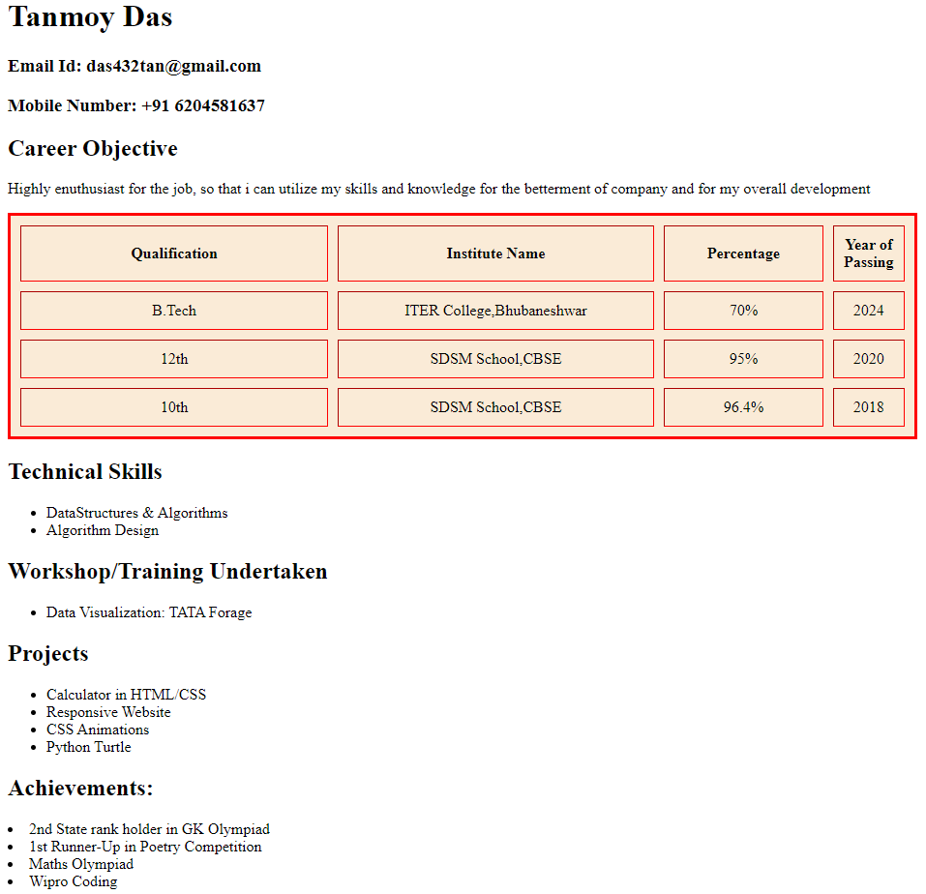

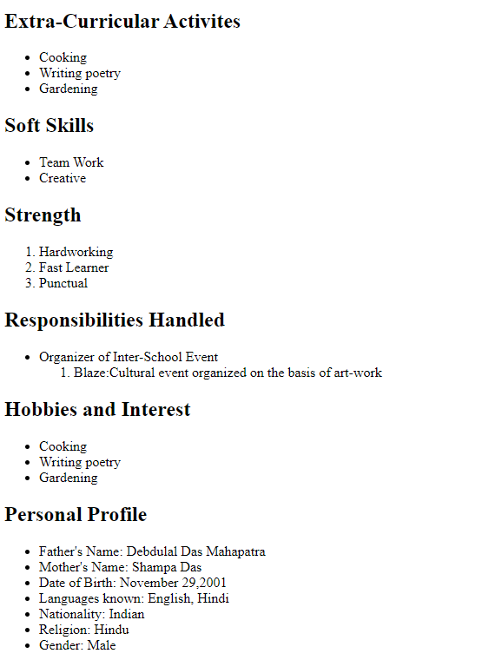

Name- Yash Raj

Regd. No.- 2041018031

Branch/sec- CSIT ‘C’

2**) ASSIGNMENT 2**: Create a list of your Dream companies using List. Mention name of companies , CEO , Chairman , Mission Statement and Vision Statement of the companies listed.

<!DOCTYPE html>

<html lang="en">

<head>

<meta charset="UTF-8">

<meta http-equiv="X-UA-Compatible" content="IE=edge">

<meta name="viewport" content="width=device-width, initial-scale=1.0">

<title>Software Companies</title>

</head>

<body>

<h1>Microsoft</h1>

<ul>

<li>

<h2>CEO:</h2>

Satya Nadella

</li>

<li>

<h2>Chairman: </h2>

Satya Nadella

</li>

<li>

<h2>Product/Services:</h2> <br>

<ol>

<li>Hardware</li>

<li>Software development</li>

<li>Productivity</li>

<li>web and subscription services</li>

<li>Video games</li>

<li>Operating System</li>

<li>Maintenance</li>

</ol>

</li>

<li>

<h2>Vision Statement:</h2>

we believe in what people make possible.

</li>

<li>

<h2>Mission Statement: </h2>

Our mission is to empower every person and every organization on the planet to achieve more.

</li>

</ul>

<hr>

<h1>Oracle</h1>

<ul>

<li>

<h2>CEO:</h2>

<ul>

<li>Larry Ellison</li>

<li>Safra Catz</li>

</ul>

</li>

<li>

<h2>Chairman:</h2>

Larry Ellison

</li>

<li>

<h2>Product/Services:</h2>

<ol>

<li>Oracle Cloud Infrastructure</li>

<li>Cloud Applications</li>

<li>Industries</li>

<li>Oracle Hardware and Engineered Systems</li>

<li>Enterprise Applications</li>

<li>Oracle Featured Software</li>

</ol>

<li>

<h2>Vision Statement:</h2>

Efforts in the area of sustainability, education giving, volunteering and more.

</li>

<li>

<h2>Mission Statement:</h2>

Our mission is to help people see data in new ways, discover insights,unlock endless possibilities.

</li>

</ul>

<hr>

<h1>SAP</h1>

<ul>

<li>

<h2>CEO:</h2>

Christian Klein

</li>

<li>

<h2>Chairman:</h2>

Hasso Plattner

</li>

<li>

<h2>Product/Services:</h2>

<ol>

<li>Enterprise Resource Planning</li>

<li>Financial Management</li>

<li>Spend Management</li>

</ol>

</li>

<li>

<h2>Vision Statement:</h2>

Our purpose is to help the world run better and improve people's lives. Our promise is to innovate to help

our customers run at their best.

</li>

<li>

<h2>Mission Statement:</h2>

We engineer solutions to fuel innovation, foster equality, and spread opportunity across borders and

cultures.

</li>

</ul>

<hr>

<h1>IBM</h1>

<ul>

<li>

<h2>CEO:</h2>

Arvind Krishna

</li>

<li>

<h2>Chairman:</h2>

Ginni Rometty

</li>

<li>

<h2>Product/Services:</h2>

<ol>

<li>Analytics</li>

<li>Cybersecurity</li>

<li>Cloud</li>

<li>Blockchain</li>

</ol>

</li>

<li>

<h2>Vision Statement:</h2>

We believe that through the application of intelligence, reason and science, we can improve business,

society and the human condition.

</li>

<li>

<h2>Mission Statement:</h2>

Our mission and purpose is to be a catalyst that makes the world work better.

</li>

</ul>

<hr>

<h1>Salesforce.com</h1>

<ul>

<li>

<h2>CEO:</h2>

Marc Benioff

<br>

Laura J. Alber

</li>

<li>

<h2>Chairman:</h2>

Mark Benioff

</li>

<li>

<h2>Product/Services:</h2>

<ol>

<li>Sales Cloud</li>

<li>Service Cloud</li>

<li>App Cloud </li>

<li>IOT Cloud</li>

</ol>

</li>

<li>

<h2>Vision Statement:</h2>

We believe that business of business is to improve the state of the world, and we work to make sure

Salesforce is a platform for change.

</li>

<li>

<h2>Mission Statement:</h2>

The company was founded on three disruptive ideas: a new technology model in cloud computing, a pay-as-you

go business model, and a new integrated corporate philanthropy model.

</li>

</ul>

<hr>

<h1>Adobe</h1>

<ul>

<li>

<h2>CEO:</h2>

Shantanu Narayan

</li>

<li>

<h2>Chairman:</h2>

Shantanu Narayan

</li>

<li>

<h2>Product/Services:</h2>

<ol>

<li>Acrobat</li>

<li>Photoshop</li>

<li>Adobe Stock</li>

<li>Illustrator</li>

</ol>

</li>

<li>

<h2>Vision Statement:</h2>

Changing the world through digital experience.

</li>

<li>

<h2>Mission Statement:</h2>

Great experiences have the power to inspire, transform and move the world forward.

</li>

</ul>

<hr>

<h1>Fiserv</h1>

<ul>

<li>

<h2>CEO:</h2>

Frank Bisignano

</li>

<li>

<h2>Chairman:</h2>

Frank Bisignano

</li>

<li>

<h2>Product/Services:</h2>

<ol>

<li>Digital Documents</li>

<li>Direct Marketing & Loyalty</li>

<li>Secure Payment Cards</li>

<li>Sourced Supplies</li>

</ol>

</li>

<li>

<h2>Vision Statement:</h2>

Our aspiration is to more money and information in a way that moves the world

</li>

<li>

<h2>Mission Statement:</h2>

Our purpose is to deliver superior value for our clients through leading technology,targeted innovation,and

excellence in everything we do.

</li>

</ul>

<hr>

<h1>ADP</h1>

<ul>

<li>

<h2>CEO:</h2>

Carlos A. Rodriguez

</li>

<li>

<h2>Chairman:</h2>

Arthur F. Weinbach

</li>

<li>

<h2>Product/Services:</h2>

<ol>

<li>Small Business Payroll Services.</li>

<li>Medium to Large Payroll Services.</li>

<li>Payroll for Global Employees.</li>

<li>What is Outsourcing Payroll Services.</li>

<li>Payroll Outsourcing.</li>

</ol>

</li>

<li>

<h2>Vision Statement:</h2>

Always designing for people means we'll never stop removing obstacles and making work more open, so everyone

can focus on doing what they do best. It means we are always designing for tomorrow. That's our business,

our purpose, and our passion.

</li>

<li>

<h2>Mission Statement:</h2>

We create experiences, products, and services that people love using every day.

</li>

</ul>

<hr>

<h1>Dell Technology</h1>

<ul>

<li>

<h2>CEO:</h2>

Michael S. Dell

</li>

<li>

<h2>Chairman:</h2>

Michael S. Dell

</li>

<li>

<h2>Product/Services:</h2>

<ol>

<li>OptiPlex (office desktop computer systems)</li>

<li>Dimension (home desktop computer systems)</li>

<li>Vostro (office/small business desktop and notebook systems)</li>

<li>n Series (desktop and notebook computers shipped with Linux or FreeDOS installed)</li>

<li>Latitude (business-focused notebooks)</li>

<li>Precision (workstation systems and high-performance "Mobile Workstation" notebooks),[208]</li>

<li>PowerEdge (business servers)</li>

<li>PowerVault (direct-attach and network-attached storage)</li>

<li>Force10 (network switches)</li>

</ol>

</li>

<li>

<h2>Vision Statement:</h2>

“It's the way we do business. It's the way we interact with the community. It's the way we interpret the

world around us- our customers' needs, the future of technology, and the global business climate.

</li>

<li>

<h2>Mission Statement:</h2>

Dell Technologies is a unique family of businesses that helps organizations and individuals build their

digital future and transform how they work, live and play. The company provides customers with the

industry's broadest and most innovative technology and services portfolio spanning from edge to core to

cloud. We value our customers, winning together, innovation, results and integrity.

</li>

</ul>

<hr>

<h1>Broadcom</h1>

<ul>

<li>

<h2>CEO:</h2>

Hock E. Tan

</li>

<li>

<h2>Chairman:</h2>

Hock E. Tan

</li>

<li>

<h2>Product/Services:</h2>

<ol>

<li>Wired Connectivity</li>

<li>Optical Products</li>

<li>Mainframe Software</li>

<li>Cybersecurity</li>

</ol>

</li>

<li>

<h2>Vision Statement:</h2>

Broadcom Inc. combines global scale, engineering depth, broad product portfolio diversity and superior

execution and operational focus to deliver category-leading connectivity products so its customers can build

and grow successful businesses today and in the future.

</li>

<li>

<h2>Mission Statement:</h2>

Broadcom's extensive product portfolio serves multiple applications within four primary end markets: wired

infrastructure, wireless communications, enterprise storage and industrial & others. Applications for our

products in these end markets include: data center networking, home connectivity, broadband access,

telecommunications equipment, smartphones and base stations, data center servers and storage, factory

automation, power generation and alternative energy systems, and displays.

</li>

</ul>

</body>

</html>

OUTPUT:

**Microsoft**

* **CEO:**

Satya Nadella

* **Chairman:**

Satya Nadella

* **Product/Services:**
  1. Hardware
  2. Software development
  3. Productivity
  4. web and subscription services
  5. Video games
  6. Operating System
  7. Maintenance
* **Vision Statement:**

we believe in what people make possible.

* **Mission Statement:**

Our mission is to empower every person and every organization on the planet to achieve more.

**Oracle**

* **CEO:**
  + Larry Ellison
  + Safra Catz
* **Chairman:**

Larry Ellison

* **Product/Services:**
  + Oracle Cloud Infrastructure
  + Cloud Applications
  + Industries
  + Oracle Hardware and Engineered Systems
  + Enterprise Applications
  + Oracle Featured Software
* **Vision Statement:**

Efforts in the area of sustainability, education giving, volunteering and more.

* **Mission Statement:**

Our mission is to help people see data in new ways, discover insights,unlock endless possibilities.

**SAP**

* **CEO:**

Christian Klein

* **Chairman:**

Hasso Plattner

* **Product/Services:**
  1. Enterprise Resource Planning
  2. Financial Management
  3. Spend Management
* **Vision Statement:**

Our purpose is to help the world run better and improve people's lives. Our promise is to innovate to help our customers run at their best.

* **Mission Statement:**

We engineer solutions to fuel innovation, foster equality, and spread opportunity across borders and cultures.

**IBM**

* **CEO:**

Arvind Krishna

* **Chairman:**

Ginni Rometty

* **Product/Services:**
  1. Analytics
  2. Cybersecurity
  3. Cloud
  4. Blockchain
* **Vision Statement:**

We believe that through the application of intelligence, reason and science, we can improve business, society and the human condition.

* **Mission Statement:**

Our mission and purpose is to be a catalyst that makes the world work better.

**Salesforce.com**

* **CEO:**

Marc Benioff  
Laura J. Alber

* **Chairman:**

Mark Benioff

* **Product/Services:**
  1. Sales Cloud
  2. Service Cloud
  3. App Cloud
  4. IOT Cloud
* **Vision Statement:**

We believe that business of business is to improve the state of the world, and we work to make sure Salesforce is a platform for change.

* **Mission Statement:**

The company was founded on three disruptive ideas: a new technology model in cloud computing, a pay-as-you go business model, and a new integrated corporate philanthropy model.

**Adobe**

* **CEO:**

Shantanu Narayan

* **Chairman:**

Shantanu Narayan

* **Product/Services:**
  1. Acrobat
  2. Photoshop
  3. Adobe Stock
  4. Illustrator
* **Vision Statement:**

Changing the world through digital experience.

* **Mission Statement:**

Great experiences have the power to inspire, transform and move the world forward.

**Fiserv**

* **CEO:**

Frank Bisignano

* **Chairman:**

Frank Bisignano

* **Product/Services:**
  1. Digital Documents
  2. Direct Marketing & Loyalty
  3. Secure Payment Cards
  4. Sourced Supplies
* **Vision Statement:**

Our aspiration is to more money and information in a way that moves the world

* **Mission Statement:**

Our purpose is to deliver superior value for our clients through leading technology,targeted innovation,and excellence in everything we do.

**ADP**

* **CEO:**

Carlos A. Rodriguez

* **Chairman:**

Arthur F. Weinbach

* **Product/Services:**
  1. Small Business Payroll Services.
  2. Medium to Large Payroll Services.
  3. Payroll for Global Employees.
  4. What is Outsourcing Payroll Services.
  5. Payroll Outsourcing.
* **Vision Statement:**

Always designing for people means we'll never stop removing obstacles and making work more open, so everyone can focus on doing what they do best. It means we are always designing for tomorrow. That's our business, our purpose, and our passion.

* **Mission Statement:**

We create experiences, products, and services that people love using every day.

**Dell Technology**

* **CEO:**

Michael S. Dell

* **Chairman:**

Michael S. Dell

* **Product/Services:**
  1. OptiPlex (office desktop computer systems)
  2. Dimension (home desktop computer systems)
  3. Vostro (office/small business desktop and notebook systems)
  4. n Series (desktop and notebook computers shipped with Linux or FreeDOS installed)
  5. Latitude (business-focused notebooks)
  6. Precision (workstation systems and high-performance "Mobile Workstation" notebooks),[208]
  7. PowerEdge (business servers)
  8. PowerVault (direct-attach and network-attached storage)
  9. Force10 (network switches)
* **Vision Statement:**

“It's the way we do business. It's the way we interact with the community. It's the way we interpret the world around us- our customers' needs, the future of technology, and the global business climate.

* **Mission Statement:**

Dell Technologies is a unique family of businesses that helps organizations and individuals build their digital future and transform how they work, live and play. The company provides customers with the industry's broadest and most innovative technology and services portfolio spanning from edge to core to cloud. We value our customers, winning together, innovation, results and integrity.

**Broadcom**

* **CEO:**

Hock E. Tan

* **Chairman:**

Hock E. Tan

* **Product/Services:**
  1. Wired Connectivity
  2. Optical Products
  3. Mainframe Software
  4. Cybersecurity
* **Vision Statement:**

Broadcom Inc. combines global scale, engineering depth, broad product portfolio diversity and superior execution and operational focus to deliver category-leading connectivity products so its customers can build and grow successful businesses today and in the future.

* **Mission Statement:**

Broadcom's extensive product portfolio serves multiple applications within four primary end markets: wired infrastructure, wireless communications, enterprise storage and industrial & others. Applications for our products in these end markets include: data center networking, home connectivity, broadband access, telecommunications equipment, smartphones and base stations, data center servers and storage, factory automation, power generation and alternative energy systems, and displays.

Name- Yash Raj

Regd. No.- 2041018031

Branch/sec- CSIT ‘C’

3)**ASSIGNMENT 3**: Create a list of your dream companies same to that in Assignment 2, and add company image for each company. Add links of the company’s website to the image of the logo so that it opens the website on clicking the company logo.

<!DOCTYPE html>

<html lang="en">

<head>

<meta charset="UTF-8">

<meta http-equiv="X-UA-Compatible" content="IE=edge">

<meta name="viewport" content="width=device-width, initial-scale=1.0">

<title>Software Companies</title>

</head>

<body>

<h1>Microsoft</h1>

<a href="https://www.microsoft.com"><img src="images/microsoft.png" alt=""></a>

<ul>

<li>

<h2>CEO:</h2>

Satya Nadella

</li>

<li>

<h2>Chairman: </h2>

Satya Nadella

</li>

<li>

<h2>Product/Services:</h2> <br>

<ol>

<li>Hardware</li>

<li>Software development</li>

<li>Productivity</li>

<li>web and subscription services</li>

<li>Video games</li>

<li>Operating System</li>

<li>Maintenance</li>

</ol>

</li>

<li>

<h2>Vision Statement:</h2>

we believe in what people make possible.

</li>

<li>

<h2>Mission Statement: </h2>

Our mission is to empower every person and every organization on the planet to achieve more.

</li>

</ul>

<hr>

<h1>Oracle</h1>

<a href="https://www.oracle.com"><img src="images/oracle.png" alt=""></a>

<ul>

<li>

<h2>CEO:</h2>

<ul>

<li>Larry Ellison</li>

<li>Safra Catz</li>

</ul>

</li>

<li>

<h2>Chairman:</h2>

Larry Ellison

</li>

<li>

<h2>Product/Services:</h2>

<ol>

<li>Oracle Cloud Infrastructure</li>

<li>Cloud Applications</li>

<li>Industries</li>

<li>Oracle Hardware and Engineered Systems</li>

<li>Enterprise Applications</li>

<li>Oracle Featured Software</li>

</ol>

<li>

<h2>Vision Statement:</h2>

Efforts in the area of sustainability, education giving, volunteering and more.

</li>

<li>

<h2>Mission Statement:</h2>

Our mission is to help people see data in new ways, discover insights,unlock endless possibilities.

</li>

</ul>

<hr>

<h1>SAP</h1>

<a href="https://www.sap.com"><img src="images/SAP.png" alt=""></a>

<ul>

<li>

<h2>CEO:</h2>

Christian Klein

</li>

<li>

<h2>Chairman:</h2>

Hasso Plattner

</li>

<li>

<h2>Product/Services:</h2>

<ol>

<li>Enterprise Resource Planning</li>

<li>Financial Management</li>

<li>Spend Management</li>

</ol>

</li>

<li>

<h2>Vision Statement:</h2>

Our purpose is to help the world run better and improve people's lives. Our promise is to innovate to help

our customers run at their best.

</li>

<li>

<h2>Mission Statement:</h2>

We engineer solutions to fuel innovation, foster equality, and spread opportunity across borders and

cultures.

</li>

</ul>

<hr>

<h1>IBM</h1>

<a href="https://www.ibm.com"><img src="images/IBM.jpg" alt=""></a>

<ul>

<li>

<h2>CEO:</h2>

Arvind Krishna

</li>

<li>

<h2>Chairman:</h2>

Ginni Rometty

</li>

<li>

<h2>Product/Services:</h2>

<ol>

<li>Analytics</li>

<li>Cybersecurity</li>

<li>Cloud</li>

<li>Blockchain</li>

</ol>

</li>

<li>

<h2>Vision Statement:</h2>

We believe that through the application of intelligence, reason and science, we can improve business,

society and the human condition.

</li>

<li>

<h2>Mission Statement:</h2>

Our mission and purpose is to be a catalyst that makes the world work better.

</li>

</ul>

<hr>

<h1>Salesforce.com</h1>

<a href="https://www.salesforce.com"><img src="images/salesforce.png" alt=""></a>

<ul>

<li>

<h2>CEO:</h2>

Marc Benioff

<br>

Laura J. Alber

</li>

<li>

<h2>Chairman:</h2>

Mark Benioff

</li>

<li>

<h2>Product/Services:</h2>

<ol>

<li>Sales Cloud</li>

<li>Service Cloud</li>

<li>App Cloud </li>

<li>IOT Cloud</li>

</ol>

</li>

<li>

<h2>Vision Statement:</h2>

We believe that business of business is to improve the state of the world, and we work to make sure

Salesforce is a platform for change.

</li>

<li>

<h2>Mission Statement:</h2>

The company was founded on three disruptive ideas: a new technology model in cloud computing, a pay-as-you

go business model, and a new integrated corporate philanthropy model.

</li>

</ul>

<hr>

<h1>Adobe</h1>

<a href="https://www.adobe.com"><img src="images/Adobe.png" alt=""></a>

<ul>

<li>

<h2>CEO:</h2>

Shantanu Narayan

</li>

<li>

<h2>Chairman:</h2>

Shantanu Narayan

</li>

<li>

<h2>Product/Services:</h2>

<ol>

<li>Acrobat</li>

<li>Photoshop</li>

<li>Adobe Stock</li>

<li>Illustrator</li>

</ol>

</li>

<li>

<h2>Vision Statement:</h2>

Changing the world through digital experience.

</li>

<li>

<h2>Mission Statement:</h2>

Great experiences have the power to inspire, transform and move the world forward.

</li>

</ul>

<hr>

<h1>Fiserv</h1>

<a href="https://www.fiserv.com"><img src="images/fiserv.png" alt=""></a>

<ul>

<li>

<h2>CEO:</h2>

Frank Bisignano

</li>

<li>

<h2>Chairman:</h2>

Frank Bisignano

</li>

<li>

<h2>Product/Services:</h2>

<ol>

<li>Digital Documents</li>

<li>Direct Marketing & Loyalty</li>

<li>Secure Payment Cards</li>

<li>Sourced Supplies</li>

</ol>

</li>

<li>

<h2>Vision Statement:</h2>

Our aspiration is to more money and information in a way that moves the world

</li>

<li>

<h2>Mission Statement:</h2>

Our purpose is to deliver superior value for our clients through leading technology,targeted innovation,and

excellence in everything we do.

</li>

</ul>

<hr>

<h1>ADP</h1>

<a href="https://www.adp.com"><img src="images/adp.png" alt=""></a>

<ul>

<li>

<h2>CEO:</h2>

Carlos A. Rodriguez

</li>

<li>

<h2>Chairman:</h2>

Arthur F. Weinbach

</li>

<li>

<h2>Product/Services:</h2>

<ol>

<li>Small Business Payroll Services.</li>

<li>Medium to Large Payroll Services.</li>

<li>Payroll for Global Employees.</li>

<li>What is Outsourcing Payroll Services.</li>

<li>Payroll Outsourcing.</li>

</ol>

</li>

<li>

<h2>Vision Statement:</h2>

Always designing for people means we'll never stop removing obstacles and making work more open, so everyone

can focus on doing what they do best. It means we are always designing for tomorrow. That's our business,

our purpose, and our passion.

</li>

<li>

<h2>Mission Statement:</h2>

We create experiences, products, and services that people love using every day.

</li>

</ul>

<hr>

<h1>Dell Technology</h1>

<a href="https://www.dell.com"><img src="images/dell.png" alt=""></a>

<ul>

<li>

<h2>CEO:</h2>

Michael S. Dell

</li>

<li>

<h2>Chairman:</h2>

Michael S. Dell

</li>

<li>

<h2>Product/Services:</h2>

<ol>

<li>OptiPlex (office desktop computer systems)</li>

<li>Dimension (home desktop computer systems)</li>

<li>Vostro (office/small business desktop and notebook systems)</li>

<li>n Series (desktop and notebook computers shipped with Linux or FreeDOS installed)</li>

<li>Latitude (business-focused notebooks)</li>

<li>Precision (workstation systems and high-performance "Mobile Workstation" notebooks),[208]</li>

<li>PowerEdge (business servers)</li>

<li>PowerVault (direct-attach and network-attached storage)</li>

<li>Force10 (network switches)</li>

</ol>

</li>

<li>

<h2>Vision Statement:</h2>

“It's the way we do business. It's the way we interact with the community. It's the way we interpret the

world around us- our customers' needs, the future of technology, and the global business climate.

</li>

<li>

<h2>Mission Statement:</h2>

Dell Technologies is a unique family of businesses that helps organizations and individuals build their

digital future and transform how they work, live and play. The company provides customers with the

industry's broadest and most innovative technology and services portfolio spanning from edge to core to

cloud. We value our customers, winning together, innovation, results and integrity.

</li>

</ul>

<hr>

<h1>Broadcom</h1>

<a href="https://www.broadcom.com"><img src="images/broadcom.png" alt=""></a>

<ul>

<li>

<h2>CEO:</h2>

Hock E. Tan

</li>

<li>

<h2>Chairman:</h2>

Hock E. Tan

</li>

<li>

<h2>Product/Services:</h2>

<ol>

<li>Wired Connectivity</li>

<li>Optical Products</li>

<li>Mainframe Software</li>

<li>Cybersecurity</li>

</ol>

</li>

<li>

<h2>Vision Statement:</h2>

Broadcom Inc. combines global scale, engineering depth, broad product portfolio diversity and superior

execution and operational focus to deliver category-leading connectivity products so its customers can build

and grow successful businesses today and in the future.

</li>

<li>

<h2>Mission Statement:</h2>

Broadcom's extensive product portfolio serves multiple applications within four primary end markets: wired

infrastructure, wireless communications, enterprise storage and industrial & others. Applications for our

products in these end markets include: data center networking, home connectivity, broadband access,

telecommunications equipment, smartphones and base stations, data center servers and storage, factory

automation, power generation and alternative energy systems, and displays.

</li>

</ul>

</body>

</html>

**Microsoft**

[](https://www.microsoft.com/)

* **CEO:**

Satya Nadella

* **Chairman:**

Satya Nadella

* **Product/Services:**
  1. Hardware
  2. Software development
  3. Productivity
  4. web and subscription services
  5. Video games
  6. Operating System
  7. Maintenance
* **Vision Statement:**

we believe in what people make possible.

* **Mission Statement:**

Our mission is to empower every person and every organization on the planet to achieve more.

**Oracle**

[](https://www.oracle.com/)

* **CEO:**
  + Larry Ellison
  + Safra Catz
* **Chairman:**

Larry Ellison

* **Product/Services:**
  + Oracle Cloud Infrastructure
  + Cloud Applications
  + Industries
  + Oracle Hardware and Engineered Systems
  + Enterprise Applications
  + Oracle Featured Software
* **Vision Statement:**

Efforts in the area of sustainability, education giving, volunteering and more.

* **Mission Statement:**

Our mission is to help people see data in new ways, discover insights,unlock endless possibilities.

**SAP**

[](https://www.sap.com/)

* **CEO:**

Christian Klein

* **Chairman:**

Hasso Plattner

* **Product/Services:**
  1. Enterprise Resource Planning
  2. Financial Management
  3. Spend Management
* **Vision Statement:**

Our purpose is to help the world run better and improve people's lives. Our promise is to innovate to help our customers run at their best.

* **Mission Statement:**

We engineer solutions to fuel innovation, foster equality, and spread opportunity across borders and cultures.

**IBM**

[](https://www.ibm.com/)

* **CEO:**

Arvind Krishna

* **Chairman:**

Ginni Rometty

* **Product/Services:**
  1. Analytics
  2. Cybersecurity
  3. Cloud
  4. Blockchain
* **Vision Statement:**

We believe that through the application of intelligence, reason and science, we can improve business, society and the human condition.

* **Mission Statement:**

Our mission and purpose is to be a catalyst that makes the world work better.

**Salesforce.com**

[](https://www.salesforce.com/)

* **CEO:**

Marc Benioff  
Laura J. Alber

* **Chairman:**

Mark Benioff

* **Product/Services:**
  1. Sales Cloud
  2. Service Cloud
  3. App Cloud
  4. IOT Cloud
* **Vision Statement:**

We believe that business of business is to improve the state of the world, and we work to make sure Salesforce is a platform for change.

* **Mission Statement:**

The company was founded on three disruptive ideas: a new technology model in cloud computing, a pay-as-you go business model, and a new integrated corporate philanthropy model.

**Adobe**

[](https://www.adobe.com/)

* **CEO:**

Shantanu Narayan

* **Chairman:**

Shantanu Narayan

* **Product/Services:**
  1. Acrobat
  2. Photoshop
  3. Adobe Stock
  4. Illustrator
* **Vision Statement:**

Changing the world through digital experience.

* **Mission Statement:**

Great experiences have the power to inspire, transform and move the world forward.

**Fiserv**

[](https://www.fiserv.com/)

* **CEO:**

Frank Bisignano

* **Chairman:**

Frank Bisignano

* **Product/Services:**
  1. Digital Documents
  2. Direct Marketing & Loyalty
  3. Secure Payment Cards
  4. Sourced Supplies
* **Vision Statement:**

Our aspiration is to more money and information in a way that moves the world

* **Mission Statement:**

Our purpose is to deliver superior value for our clients through leading technology,targeted innovation,and excellence in everything we do.

**ADP**

[](https://www.adp.com/)

* **CEO:**

Carlos A. Rodriguez

* **Chairman:**

Arthur F. Weinbach

* **Product/Services:**
  1. Small Business Payroll Services.
  2. Medium to Large Payroll Services.
  3. Payroll for Global Employees.
  4. What is Outsourcing Payroll Services.
  5. Payroll Outsourcing.
* **Vision Statement:**

Always designing for people means we'll never stop removing obstacles and making work more open, so everyone can focus on doing what they do best. It means we are always designing for tomorrow. That's our business, our purpose, and our passion.

* **Mission Statement:**

We create experiences, products, and services that people love using every day.

**Dell Technology**

[](https://www.dell.com/)

* **CEO:**

Michael S. Dell

* **Chairman:**

Michael S. Dell

* **Product/Services:**
  1. OptiPlex (office desktop computer systems)
  2. Dimension (home desktop computer systems)
  3. Vostro (office/small business desktop and notebook systems)
  4. n Series (desktop and notebook computers shipped with Linux or FreeDOS installed)
  5. Latitude (business-focused notebooks)
  6. Precision (workstation systems and high-performance "Mobile Workstation" notebooks),[208]
  7. PowerEdge (business servers)
  8. PowerVault (direct-attach and network-attached storage)
  9. Force10 (network switches)
* **Vision Statement:**

“It's the way we do business. It's the way we interact with the community. It's the way we interpret the world around us- our customers' needs, the future of technology, and the global business climate.

* **Mission Statement:**

Dell Technologies is a unique family of businesses that helps organizations and individuals build their digital future and transform how they work, live and play. The company provides customers with the industry's broadest and most innovative technology and services portfolio spanning from edge to core to cloud. We value our customers, winning together, innovation, results and integrity.

**Broadcom**

[](https://www.broadcom.com/)

* **CEO:**

Hock E. Tan

* **Chairman:**

Hock E. Tan

* **Product/Services:**
  1. Wired Connectivity
  2. Optical Products
  3. Mainframe Software
  4. Cybersecurity
* **Vision Statement:**

Broadcom Inc. combines global scale, engineering depth, broad product portfolio diversity and superior execution and operational focus to deliver category-leading connectivity products so its customers can build and grow successful businesses today and in the future.

* **Mission Statement:**

Broadcom's extensive product portfolio serves multiple applications within four primary end markets: wired infrastructure, wireless communications, enterprise storage and industrial & others. Applications for our products in these end markets include: data center networking, home connectivity, broadband access, telecommunications equipment, smartphones and base stations, data center servers and storage, factory automation, power generation and alternative energy systems, and displays.

Name- Yash Raj

Regd. No.- 2041018031

Branch/sec- CSIT ‘C’

4**) ASSIGNMENT 4**: Map an Image consisting google services, such that on clicking on each services will open the specific service on a separate page.

<!DOCTYPE html>

<html lang="en">

<head>

<meta charset="UTF-8">

<meta http-equiv="X-UA-Compatible" content="IE=edge">

<meta name="viewport" content="width=device-width, initial-scale=1.0">

<title>Document</title>

</head>

<body>

<img src="images/WhatsApp Image 2022-10-10 at 12.48.04.jpg" alt="" usemap="#workmap">

<map name="workmap">

<area shape="rect" coords="107,244,232,367" href="https://www.google.co.in/" alt="" target="_blank">

<area shape="rect" coords="293,245,418,368" href="https://g.co/kgs/TV6Knj" alt="" target="_blank">

<area shape="rect" coords="485,245,610,368" href="https://www.youtube.com/" alt="" target="_blank">

<area shape="rect" coords="671,244,796,367" href="https://www.google.com/maps" alt="" target="_blank">

<area shape="rect" coords="106,506,231,629" href="https://www.google.com/intl/en_in/drive/" alt="" target="_blank">

<area shape="rect" coords="295,508,420,631" href="https://music.youtube.com/" alt="" target="_blank">

<area shape="rect" coords="482,509,607,632" href="https://play.google.com" alt="" target="_blank">

<area shape="rect" coords="672,509,797,632" href="https://g.co/kgs/D3AZM5" alt="" target="_blank">

<area shape="rect" coords="107,771,232,894" href="https://g.co/kgs/R3ox1f" alt="" target="_blank">

<area shape="rect" coords="294,774,419,897" href="https://news.google.com/" alt="" target="_blank">

<area shape="rect" coords="482,771,607,894" href="https://g.co/kgs/44cRg2" alt="" target="_blank">

<area shape="rect" coords="671,773,796,896" href="https://g.co/kgs/gCYEiS" alt="" target="_blank">

<area shape="rect" coords="106,1036,231,1159" href="https://g.co/kgs/CXEuHo" alt="" target="_blank">

<area shape="rect" coords="294,1035,419,1158" href="https://g.co/kgs/q7A8JM" alt="" target="_blank">

</map>

</body>

</html>

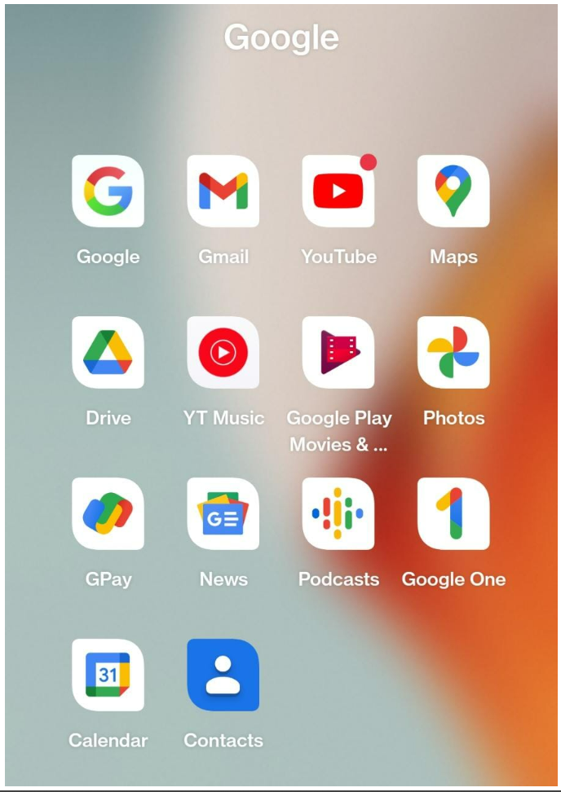

Name- Yash Raj

Regd. No.- 2041018031

Branch/sec- CSIT ‘C’

5**) ASSIGNMENT 5**: Map an Image of Indian Map for each state such that on clicking on each state a YouTube link of the regional dance of that state opens up.

<!DOCTYPE html>

<html lang="en">

<head>

<meta charset="UTF-8">

<meta http-equiv="X-UA-Compatible" content="IE=edge">

<meta name="viewport" content="width=device-width, initial-scale=1.0">

<title>India Map</title>

</head>

<body>

<img src="images/india-political-map-scaled.jpg" alt="" usemap="#workmap">

<map name="workmap">

<area shape="poly" coords="563,54,538,97,567,114,641,169,617,198,592,223,592,330,707,394,734,354,773,340,802,336,843,369,863,346,898,387,939,379,962,392,981,373,970,338,952,305,948,272,985,266,985,239,1028,221,1028,145,935,141,892,157,861,157,830,143,802,116,769,85,746,63,709,44,658,30" href="https://www.youtube.com/watch?v=E70JNtGhQYM" alt="Jammu" target="_blank">

<area shape="poly" coords="736,357,763,345,791,337,822,361,839,368,857,359,872,382,892,386,913,396,907,417,921,423,929,456,925,475,933,505,896,497,878,503,861,512,849,530,843,549,824,557,804,530,781,507,756,479,736,446,715,417,732,392" href="https://www.youtube.com/watch?v=IxvCjkeqB6c" alt="Himachal Pradesh" target="_blank">

<area shape="poly" coords="699,407,728,444,746,462,773,505,781,532,748,575,707,598,664,590,590,563,639,491,647,438" href="https://www.youtube.com/watch?v=xT-Hwodb_ho" alt="punjab" target="_blank">

<area shape="poly" coords="872,507,853,550,857,569,853,600,874,602,898,608,915,622,921,643,937,657,970,682,1003,694,1022,653,1038,618,1067,583,1026,558,997,515,976,521,950,493,931,517,900,507" href="https://www.youtube.com/watch?v=j71UyPDHGBA" alt="Uttarakhand" target="_blank">

<area shape="poly" coords="793,531,789,561,773,580,754,588,740,609,707,609,676,623,666,594,631,592,627,633,660,637,680,650,682,679,707,711,728,734,728,757,740,734,758,753,781,732,798,744,789,769,822,755,806,720,779,699,793,631,830,568" href="https://www.youtube.com/watch?v=yo_8ivkZvew" alt="Haryana" target="_blank">

<area shape="poly" coords="573,571,524,631,471,670,452,699,417,732,380,730,359,740,335,709,312,732,265,771,279,808,304,818,294,855,329,886,347,935,368,968,419,985,477,1001,512,1022,549,1081,590,1106,604,1069,623,1040,617,995,623,972,662,993,695,1011,752,1040,769,978,806,962,748,954,740,925,847,845,802,779,775,787,781,752,738,762,709,754,666,664,629,643,608,598,594,584" href="https://www.youtube.com/watch?v=mtApwvfyhvg" alt="Rajasthan" target="_blank">

<area shape="poly" coords="835,590,813,632,807,687,817,716,821,740,817,765,825,790,840,815,877,835,903,843,922,849,932,864,924,923,922,938,922,956,895,956,887,963,895,985,883,995,881,1012,883,1028,899,1045,901,1026,924,971,957,977,1000,965,1016,965,1025,979,1047,983,1093,993,1105,989,1121,991,1136,1006,1150,1014,1181,1016,1193,1037,1204,1055,1197,1067,1212,1034,1202,1078,1230,1039,1232,1002,1253,979,1294,946,1276,905,1286,880,1294,864,1284,856,1265,833,1245,808,1187,798,1134,775,1107,765,1072,734,1021,705,935,677,902,638" href="https://www.youtube.com/watch?v=If-5KWI4jI8" alt="up" target="_blank">

<area shape="poly" coords="884,846,836,868,783,899,764,920,783,938,810,936,816,953,799,973,787,1006,787,1027,771,1045,701,1064,680,1074,672,1039,670,1027,643,1008,643,1031,631,1051,633,1072,623,1109,606,1131,592,1148,581,1166,581,1179,594,1197,610,1199,614,1218,629,1220,639,1236,672,1242,688,1240,703,1257,729,1263,744,1242,763,1234,787,1230,804,1244,878,1242,902,1248,942,1248,993,1269,1011,1265,1038,1224,1057,1183,1092,1162,1110,1142,1085,1096,1104,1078,1127,1076,1157,1086,1170,1076,1166,1055,1114,1006,1007,990,935,985,917,1012,921,1029,902,1043,863,1033,865,965,884,942,907,911,915,876" href="https://www.youtube.com/watch?v=E1ORjvZlzqk" alt="mp" target="_blank">

<area shape="poly" coords="1285,810,1297,854,1306,878,1291,889,1293,917,1318,919,1343,944,1322,963,1289,961,1256,975,1240,998,1244,1018,1252,1030,1275,1028,1299,1033,1303,1047,1338,1051,1359,1043,1386,1033,1404,1018,1429,1030,1437,1043,1450,1053,1464,1035,1478,1026,1487,1004,1499,985,1515,977,1542,977,1538,956,1532,936,1542,919,1546,887,1489,889,1468,899,1423,883,1398,874,1365,860,1336,848,1320,817" href="https://www.youtube.com/watch?v=83afk6Sx2kw" alt="bihar" target="_blank">

<area shape="poly" coords="1258,1040,1246,1069,1266,1083,1283,1100,1291,1126,1305,1145,1299,1180,1305,1196,1336,1188,1357,1188,1369,1180,1375,1207,1388,1211,1420,1213,1425,1188,1449,1186,1486,1200,1460,1155,1422,1147,1416,1114,1431,1106,1460,1102,1497,1089,1527,1069,1552,1040,1552,1007,1529,989,1513,1015,1488,1038,1476,1052,1459,1061,1447,1044,1435,1036,1420,1030,1400,1046,1383,1055,1352,1065,1318,1059,1283,1048" href="https://www.youtube.com/watch?v=cpw5tpFH9ew" alt="Jharkhand" target="_blank">

<area shape="poly" coords="145,1017,174,1066,197,1089,232,1099,281,1087,308,1071,316,1095,292,1132,265,1151,217,1151,195,1149,220,1190,244,1229,275,1256,300,1274,353,1272,396,1256,419,1214,419,1184,435,1165,456,1165,464,1175,456,1208,452,1233,454,1258,454,1276,460,1303,479,1305,497,1272,528,1245,534,1204,544,1167,555,1149,559,1124,530,1093,514,1071,493,1036,481,1027,438,1003,415,997,386,986,339,1013,310,994,277,1003,250,994,191,988" href="https://www.youtube.com/watch?v=tCmsFJ3Wvm4" alt="gujrat" target="_blank">

<area shape="poly" coords="1236,1078,1209,1094,1186,1084,1120,1092,1125,1111,1141,1115,1147,1138,1135,1154,1118,1168,1104,1191,1077,1199,1065,1218,1053,1232,1042,1261,1036,1286,1028,1306,1028,1325,1028,1341,1026,1372,1020,1386,1028,1397,1050,1407,1053,1425,1053,1440,1020,1448,1005,1464,1016,1483,1032,1497,1040,1514,1048,1532,1061,1545,1083,1522,1102,1508,1125,1481,1114,1421,1104,1392,1122,1380,1137,1378,1147,1372,1135,1335,1151,1306,1178,1290,1199,1286,1215,1277,1225,1255,1240,1228,1256,1209,1268,1187,1287,1175,1279,1150,1271,1121,1256,1105" href="https://www.youtube.com/watch?v=MhHACOE48Cc" alt="chattisgarh" target="_blank">

<area shape="poly" coords="1287,1203,1256,1234,1244,1285,1234,1297,1176,1312,1159,1351,1159,1371,1176,1382,1184,1402,1166,1419,1131,1402,1135,1435,1141,1474,1135,1493,1098,1519,1096,1548,1127,1538,1153,1509,1174,1511,1188,1511,1209,1487,1223,1466,1244,1454,1266,1466,1291,1493,1314,1460,1340,1439,1365,1413,1392,1409,1431,1392,1456,1374,1474,1347,1480,1316,1482,1283,1499,1256,1458,1219,1433,1203,1408,1232,1373,1238,1351,1207" href="https://www.youtube.com/watch?v=ptKmi4TsoZ4" alt="odisha" target="_blank">

<area shape="poly" coords="1569,1017,1558,1037,1536,1066,1497,1093,1470,1107,1439,1117,1454,1144,1480,1152,1491,1185,1511,1216,1519,1237,1556,1235,1565,1216,1581,1198,1595,1214,1610,1222,1624,1202,1622,1167,1612,1130,1591,1076,1608,1045" href="https://www.youtube.com/watch?v=xHG6G-uDT-c" alt="bengal" target="_blank">

<area shape="poly" coords="555,1229,561,1256,532,1264,530,1295,522,1309,487,1316,462,1353,438,1344,440,1404,432,1437,440,1476,450,1527,458,1575,467,1624,477,1663,497,1694,520,1678,522,1649,520,1624,534,1622,553,1618,569,1610,592,1593,619,1597,633,1573,639,1548,672,1566,713,1554,775,1503,804,1453,830,1402,861,1379,909,1388,948,1400,979,1420,985,1462,1040,1425,1003,1359,1013,1297,970,1272,931,1264,865,1272,830,1277,781,1252,746,1266,711,1295,676,1268,580,1229,600,1246,649,1270" href="https://youtu.be/4YKNm2C7VP8" alt="Maharashtra" target="_blank">

<area shape="poly" coords="867,1409,820,1436,810,1469,798,1497,798,1524,793,1573,781,1606,773,1645,781,1676,779,1697,742,1713,746,1750,758,1763,812,1738,865,1715,917,1674,956,1647,1018,1612,1050,1578,1007,1532,991,1499,958,1466,954,1429" href="https://youtu.be/_-SlAdWM00g" alt="Telangana" target="_blank">

<area shape="poly" coords="781,1509,754,1596,752,1663,726,1690,723,1723,728,1746,707,1758,705,1789,703,1830,721,1861,742,1869,779,1871,808,1884,822,1908,820,1931,789,1933,761,1935,763,1962,769,2001,738,2015,697,2019,658,2017,610,1978,580,1947,563,1916,551,1851,526,1789,518,1760,528,1725,528,1711,536,1686,545,1657,543,1633,606,1612,647,1577,684,1585" href="https://youtu.be/q5k68jQ-3CU" alt="karnataka" target="_blank">

<area shape="poly" coords="736,1783,740,1820,771,1855,806,1841,822,1864,839,1905,830,1946,863,1919,894,1921,921,1905,950,1899,968,1855,970,1812,962,1769,979,1726,1011,1699,1034,1691,1061,1695,1061,1662,1098,1666,1129,1656,1147,1617,1168,1592,1205,1570,1250,1541,1281,1518,1262,1489,1250,1483,1227,1485,1174,1529,1133,1545,1073,1572,1048,1607,1020,1631,948,1672,865,1736,798,1761" href="https://youtu.be/0oZUDRXKDnM" alt="andhra" target="_blank">

<area shape="poly" coords="575,1970,590,2005,612,2029,627,2050,629,2091,643,2134,656,2190,666,2214,693,2258,711,2293,725,2284,727,2235,725,2173,695,2149,691,2114,682,2077,656,2052,654,2029,625,2009" href="https://youtu.be/968hyI0vFhk" alt="kerala" target="_blank">

<area shape="poly" coords="485,1698,516,1705,516,1742,501,1750,493,1731" href="https://youtu.be/iC1Ejmpc_og" alt="goa" target="_blank">

<area shape="poly" coords="686,2048,709,2091,719,2147,740,2147,742,2200,744,2239,734,2279,752,2309,785,2295,802,2264,808,2242,836,2225,865,2223,884,2180,900,2147,925,2135,950,2122,933,2050,933,2015,956,1995,976,1964,985,1927,966,1906,929,1927,898,1919,857,1931,839,1960,798,1944,785,1987,769,2020,726,2030" href="https://youtu.be/36CppZVh0Oo" alt="tamilnadu" target="_blank">

<area shape="poly" coords="1707,926,1690,957,1713,959,1752,967,1789,973,1834,969,1861,971,1890,973,1896,949,1879,932,1865,936,1855,908,1836,914,1813,928,1797,938,1781,928,1752,924" href="https://youtu.be/XaKsNrpqUXA" alt="meghalaya" target="_blank">

<area shape="poly" coords="1704,864,1696,893,1702,923,1737,913,1774,913,1795,915,1824,915,1848,905,1873,909,1900,930,1908,944,1910,969,1898,995,1885,1014,1879,1028,1892,1037,1912,1028,1927,1004,1937,977,1943,952,1939,934,1968,905,1984,880,2009,847,2040,823,2087,792,2097,784,2089,757,2056,763,2009,786,1992,796,1972,821,1955,831,1892,846,1875,854,1758,852" href="https://youtu.be/g6vIsYk3Ekk" alt="assam" target="_blank">

<area shape="poly" coords="1583,744,1567,775,1554,810,1563,825,1589,820,1612,816,1616,783,1604,746" href="https://youtu.be/cnQH9eRhtgg" alt="sikkim" target="_blank">

<area shape="poly" coords="1826,1039,1807,1074,1811,1105,1828,1131,1842,1107,1865,1082,1867,1043" href="https://youtu.be/DytsTSo8L8Y" alt="tripura" target="_blank">

<area shape="poly" coords="2002,651,1945,676,1914,723,1826,772,1863,799,1877,820,1951,822,1984,789,2037,748,2103,733,2124,754,2122,776,2087,811,2037,842,2015,869,1996,902,1967,916,1974,943,2011,924,2048,920,2068,896,2064,848,2103,822,2124,795,2155,770,2179,764,2204,719,2142,704,2132,676,2130,649,2112,624" href="https://youtu.be/EVjs0IUaL7I" alt="arunachal" target="_blank">

<area shape="poly" coords="2145,785,2103,826,2073,846,2073,887,2105,887,2126,900,2153,863,2153,824" href="https://youtu.be/fn9Gc7BrdLM" alt="nagaland" target="_blank">

<area shape="poly" coords="1910,1032,1883,1054,1883,1083,1892,1126,1900,1159,1925,1198,1937,1182,1941,1141,1957,1122,1966,1098,1947,1065" href="https://www.youtube.com/watch?v=xic-lsu8FvE" alt="mizoram" target="_blank">

<area shape="poly" coords="2019,932,1957,961,1937,989,1925,1018,1937,1031,1957,1033,1996,1039,2007,1039,2029,998,2042,965" href="https://youtu.be/jZ91eUDTk44" alt="imphal" target="_blank">

</map>

</body>

</html>

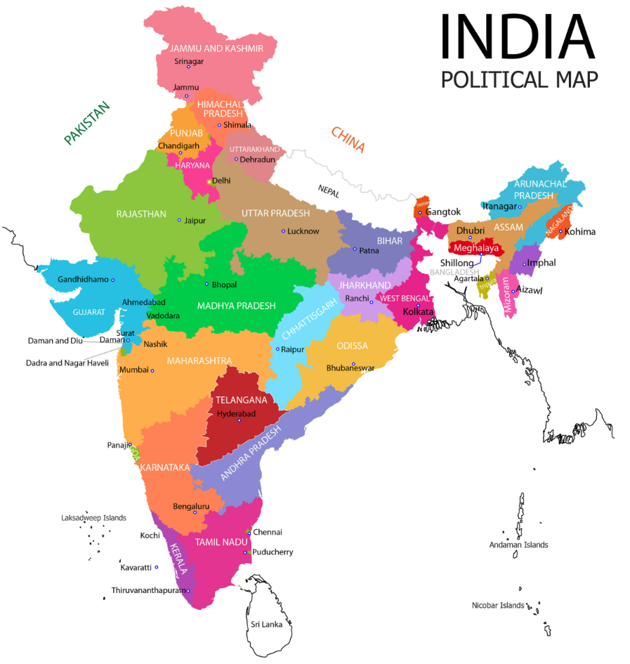

Name- Yash Raj

Regd. No.- 2041018031

Branch/sec- CSIT ‘C’

6. **Assignment 6:** Create a replica of Facebook's Login page with all the elements present including links, input-type:name,email,number,date etc

<!DOCTYPE html>

<html lang="en">

<head>

<meta charset="UTF-8">

<meta name="viewport" content="width=device-width, initial-scale=1.0">

<meta http-equiv="X-UA-Compatible" content="ie=edge">

<title>Document</title>

</head>

<body>

<form action="">

Create a new account <br> It's quick and easy <br> An error occurred.Please try again. <br> We were not able to sign you up for Facebook <br>

<label for="" name="a">First name</label>

<br>

<input type="text" name="a">

<br> Surname <br>

<input type="text" maxlength="3">

<br> Mobile number or email address <br>

<input type="email">

<br> Your Password <br>

<input type="password" name="" id="">

<br> Date of Birth <br>

<input type="datetime-local" name="" id="" pattern="[0-9]">

<br>

<br> Your Age <br>

<input type="number" name="" id="">

<br>

1<input type="range" name="" id="">10

<br>

<br>

<input type="search" name="" id="">

<br><br>

<input type="reset" value="Clear form">

<br><br>

<input type="image" src="" alt="">

<br>

<br>

<label for=" G " name="G ">Gender</label><br> Female <input type="radio " name="G " id=" "> Male <input type="radio " name="G " id=" "> Custom <input type="radio " name="G " id=" "><br>

<br>

<select name=" " id=" " multiple>

<optgroup label="Select your pronoun ">

<option value=" ">Select your pronoun</option>

<option value=" ">he/him</option>

<option value=" ">she/her</option>

<option value=" ">they/them</option>

</optgroup>

</select>

<br> Your pronoun is visible to everyone

<br> gender(optional) <br>

<input type=" " name=" " value=" ">

<br><br> People who use our service may have uploaded your contact information to Facebook.

<br><br> By clicking Sign Up, you agree to our Terms, Privacy Policy and Cookies Policy. You may receive SMS notifications.

<br><br>

<input type="button " value="Sign Up "><br> Already have an account?

<br>

<input type="button" value="" onclick="verifydata()">

<br>

<input type="file" name="" id="">

<br>

<h3>Security Check</h3>

This field is required

<label for="text">Write your question here</label><br>

<textarea name="" id="text" cols="30" rows="10" readonly></textarea>

<fieldset>

<legend name="b">Select your city</legend>

<label for="city">

<input type="radio" name="b">Bhubaneswar

</label>

<label for="city">

<input type="radio" name="b">Mumbai

</label>

<label for="city">

<input type="radio" name="b">Delhi

</label>

</fieldset>

<p>

Task progress 1:

<progress id="prog1" value="0" max="100">0%</progress>

</p>

<p>

Task progress 1:

<progress id="prog1" value="45" max="100">45%</progress>

</p>

</form>

</body>

</html>

OUTPUT:

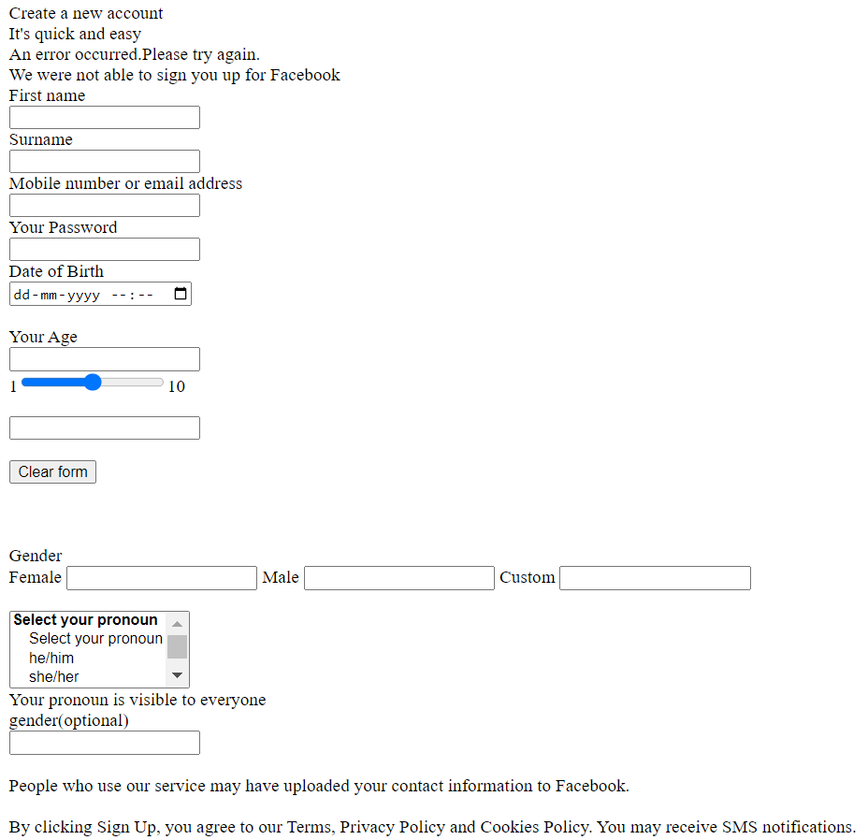

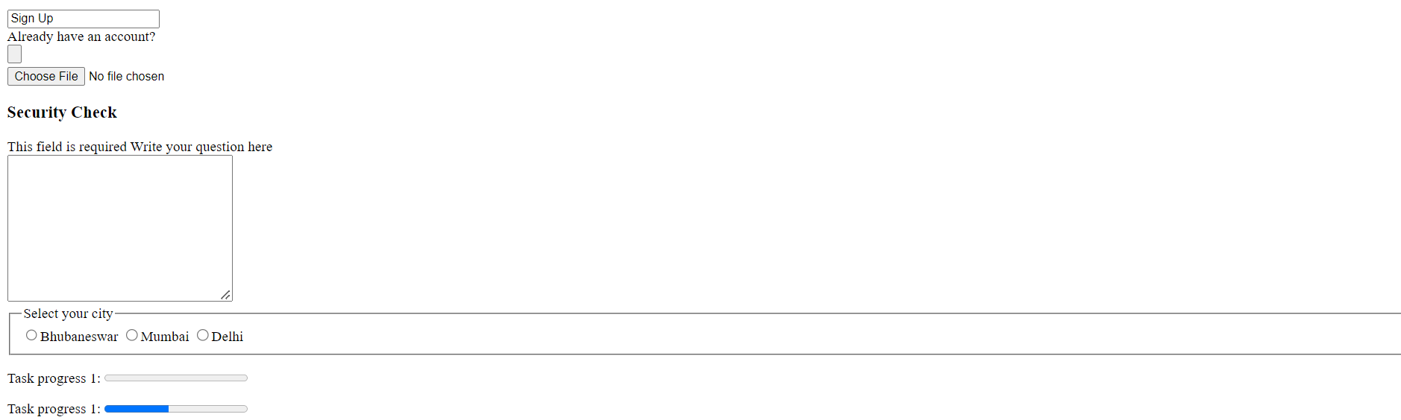

Name- Yash Raj

Regd. No.- 2041018031

Branch/sec- CSIT ‘C’

7**. Assignment 7:** Create a form using fieldset and legend. Form should consist of multiple sub forms asking for various information.

<!DOCTYPE html>

<html lang="en">

<head>

<meta charset="UTF-8">

<meta http-equiv="X-UA-Compatible" content="IE=edge">

<meta name="viewport" content="width=device-width, initial-scale=1.0">

<title>Document</title>

</head>

<body>

<h2>APPLICATION FORM</h2>

<form action="">

<fieldset style="width:90% ;">

<legend name="b">Personal Details</legend>

<table width="100%" cellspacing="10">

<tr>

<td><label for="">Applicant's full name</td>

<td><select name="" id="">

<option value="">--Select--</option>

<option value="">Mr.</option>

<option value="">Mrs.</option>

<option value="">Miss</option>

</select>

</label>

<br>

<input type="text"></td>

<td>

<label for="" name="e">Care Of</label>

</td>

<td>

Parents <input type="radio" name="e" id="">

Guardian <input type="radio" name="e" id="">

</td>

</tr>

<tr>

<td><label for="">Father's Name </td>

<td><select name="" id="">

<option value="" >Mr.</option>

</select>

</label>

<br>

<input type="text"></td>

<td><label for="">Mother's Name </td>

<td><select name="" id="">

<option value="" >Mrs.</option>

</select>

</label>

<br>

<input type="text"></td>

</tr>

<tr>

<td><label for="" name="a">Gender</label></td>

<td><input type="radio" name="a" id="">Male

<input type="radio" name="a" id="">Female

<input type="radio" name="a" id="">Others</td>

<td><label for="" name="f">Date of Birth</label></td>

<td><input type="date" name="f" id=""></td>

</tr>

<tr>

<td><label for="">Marital Status</label></td>

<td><select name="b" id="">

<option value="">--Select--</option>

<option value="">Single</option>

<option value="">Married</option>

<option value="">Widowed</option>

<option value="">Divorced</option>

</select></td>

<td><label for="" name="g">Category</label></td>

<td><select name="" id="">

<option value="" name="g">--Select--</option>

<option value="" name="g">General</option>

<option value="" name="g">SC/ST</option>

<option value="" name="g">OBC</option>

</select></td>

</tr>

<tr>

<td><label for="" name="c">Handicapped</label></td>

<td>No <input type="radio" name="c" id="">

Yes <input type="radio" name="c" id="">

</td>

<td><label for="" name="h">Ex- Serviceman</label></td>

<td>No <input type="radio" name="h" id="">

Yes <input type="radio" name="h" id=""></td>

</tr>

<tr>

<td><label for="" name="d">EWS</label></td>

<td>No <input type="radio" name="h" id="">

Yes <input type="radio" name="h" id=""></td>

<td><label for="" name="i">Religion</label></td>

<td><select name="i" id="">

<option value="">--Select--</option>

<option value="">Hindu</option>

<option value="">Christian</option>

<option value="">Sikh</option>

<option value="">Islam</option>

</select></td>

</tr>

</table>

</fieldset>

<fieldset style="width: 70%;">

<legend>Contact Details</legend>

<table width="100%" cellspacing="10">

<tr>

<td width="2%"><label for="" name="j">Mobile Number</label></td>

<td width="50%"><input type="number" name="j" id="" size="40"></td>

<td width="2%"><label for="" name="k">Email Id</label></td>

<td width="50%"><input type="email" name="k" size="40"></td>

</tr>

<tr>

<td width="2%"><label for="" name="j">Address Line 1</label></td>

<td width="50%"><input type="text" name="j" id="" size="40"></td>

<td width="2%"><label for="" name="k">Address Line 2</label></td>

<td width="50%"><input type="text" name="k" size="40"></td>

</tr>

<tr>

<td width="2%"><label for="" name="j">City</label></td>

<td width="50%"><input type="text" name="j" id="" size="40"></td>

<td width="2%"><label for="" name="k">States</label></td>

<td width="50%"><select name="" id="">

<option value="">--Select--</option>

<option value="">West Bengal</option>

<option value="">Jharkhand</option>

<option value="">Odisha</option>

<option value="">Assam</option>

</select></td>

</tr>

<tr>

<td width="2%"><label for="" name="j">Pincode</label></td>

<td width="50%"><input type="number" name="j" id="" size="40"></td>

</tr>

</table>

</fieldset>

<fieldset>

<legend>Qualification Details</legend>

<table width="100%" style="text-align: center;">

<tr>

<th>Sr No.</th>

<th>Qualification</th>

<th>Board/University</th>

<th>Passing Year</th>

<th>Max Marks</th>

<th>Marks Obtain</th>

<th>Percentage</th>

</tr>

<tr>

<td>1</td>

<td><select name="" id="" style="text-align: center;">

<option value="">--Select--</option>

<option value="">Post Graduate</option>

<option value="">Under Graduate</option>

<option value="">12th</option>

<option value="">10th</option>

</select></td>

<td>

<input type="text">

</td>

<td>

<input type="number" name="" id="">

</td>

<td>

<input type="number" name="" id="">

</td>

<td>

<input type="number" name="" id="">

</td>

<td>

<input type="number" name="" id="">

</td>

</tr>

<tr>

<td>2</td>

<td><select name="" id="" style="text-align: center;">

<option value="">--Select--</option>

<option value="">Post Graduate</option>

<option value="">Under Graduate</option>

<option value="">12th</option>

<option value="">10th</option>

</select></td>

<td>

<input type="text">

</td>

<td>

<input type="number" name="" id="">

</td>

<td>

<input type="number" name="" id="">

</td>

<td>

<input type="number" name="" id="">

</td>

<td>

<input type="number" name="" id="">

</td>

</tr>

<tr>

<td>3</td>

<td><select name="" id="" style="text-align: center;">

<option value="">--Select--</option>

<option value="">Post Graduate</option>

<option value="">Under Graduate</option>

<option value="">12th</option>

<option value="">10th</option>

</select></td>

<td>

<input type="text">

</td>

<td>

<input type="number" name="" id="">

</td>

<td>

<input type="number" name="" id="">

</td>

<td>

<input type="number" name="" id="">

</td>

<td>

<input type="number" name="" id="">

</td>

</tr>

<tr>

<td>4</td>

<td><select name="" id="" style="text-align: center;">

<option value="">--Select--</option>

<option value="">Post Graduate</option>

<option value="">Under Graduate</option>

<option value="">12th</option>

<option value="">10th</option>

</select></td>

<td>

<input type="text">

</td>

<td>

<input type="number" name="" id="">

</td>

<td>

<input type="number" name="" id="">

</td>

<td>

<input type="number" name="" id="">

</td>

<td>

<input type="number" name="" id="">

</td>

</tr>

</table>

</fieldset>

<fieldset style="width: 45%;">

<legend>Language Knowledge</legend>

<table width="100%" style="text-align: left;">

<tr>

<th>Language</th>

<th>Reading</th>

<th>Writing</th>

<th>Spoken</th>

</tr>

<tr>

<td>Hindi</td>

<td>

<input type="checkbox" name="" id="">

</td>

<td>

<input type="checkbox" name="" id="">

</td>

<td>

<input type="checkbox" name="" id="">

</td>

</tr>

<tr>

<td>English</td>

<td>

<input type="checkbox" name="" id="">

</td>

<td>

<input type="checkbox" name="" id="">

</td>

<td>

<input type="checkbox" name="" id="">

</td>

</tr>

<tr>

<td>Urdu</td>

<td>

<input type="checkbox" name="" id="">

</td>

<td>

<input type="checkbox" name="" id="">

</td>

<td>

<input type="checkbox" name="" id="">

</td>

</tr>

</table>

</fieldset>

<fieldset>

<legend>Identification Details</legend>

<table width="100%">

<tr>

<td width="10%">Adhar Card Number</td>

<td width="40%"><input type="text" size="40"></td>

<td width="10%">PAN Card Number</td>

<td width="40%"><input type="text" size="40"></td>

</tr>

<tr>

<td>Upload Photo</td>

<td><input type="file" name="" id=""></td>

<td>Upload Signature</td>

<td><input type="file" name="" id=""></td>

</tr>

</table>

</fieldset>

<br><br>

<input type="button" value="Submit">

<input type="button" value="Back">

</form>

</body>

</html>

OUTPUT:

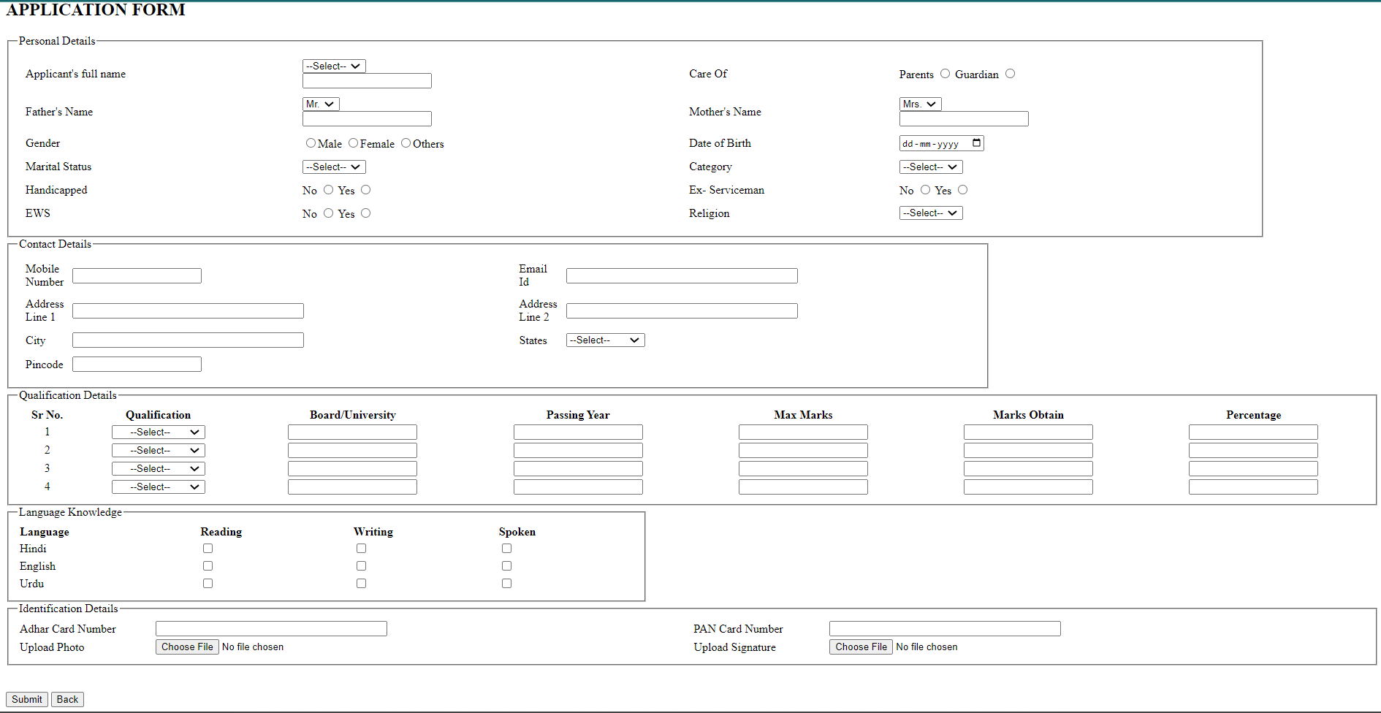

Name- Yash Raj

Regd. No.- 2041018031

Branch/sec- CSIT ‘C’

8) **ASSIGNMENT 8:** Create an HTML file displaying all the various CSS components available.

<!DOCTYPE html>

<html lang="en">

<head>

<meta charset="UTF-8">

<meta http-equiv="X-UA-Compatible" content="IE=edge">

<meta name="viewport" content="width=device-width, initial-scale=1.0">

<title>Document</title>

<link rel="stylesheet" href="css/style.css">

</head>

<body>

<div id="a1">

<p>Lorem, ipsum dolor sit amet consectetur adipisicing elit. Atque, inventore.</p>

</div>

<hr>

<div id="a">

<div id="box1">

<h4>London</h4>

<p>London is the capital of England.</p>

</div>

<div id="box2">

<h4>Paris</h4>

<p>Paris is the capital of France.</p>

</div>

<div id="box3">

<h4>Tokyo</h4>

<p>Tokyo is the capital of Japan.</p>

</div>

</div>

<hr>

<div id="b">

<h2>The font size of this heading 18pt</h2>

<table>

<tr>

<th>Living being</th>

<th>Shelter</th>

</tr>

<tr>

<td>Lion</td>

<td>Lion lives in the den</td>

</tr>

<tr>

<td>Man</td>

<td>Man lives in the house</td>

</tr>

<tr>

<td>Fish</td>

<td>Fish lives in the water</td>

</tr>

</table>

</div>

<hr>

<div id="c">

<img src="data:image/png; " alt="">

<p><b>Siksha 'O' Anusandhan</b> is a deemed university located at Bhubaneshwar, Odish, India. The university is composed of nine-degree granting schools and colleges and has a student body of around 10,000</p>

</div>

<hr>

<div id="d">

<h3>position:relative;</h3>

<p id="d1">An element with position:relative; is positioned relative to its normal position:</p>

<p id="d2">This div element has position:relative;</p>

</div>

<hr>

<div id="e">

<h1>This is heading 1</h1>

</div>

<hr>

<div id="f">

<div id="f1">

<p>Web Designing</p>

</div>

<table cellpadding="2px" cellspacing="10px">

<tr>

<td>Internet Basics</td>

</tr>

<tr>

<td>HTML</td>

</tr>

<tr>

<td>CSS</td>

</tr>

<tr>

<td>JavaScript</td>

</tr>

</table>

<h1>HTML</h1>

<p>The Hypertext Markup Language, or HTML (HyperText Markup Language) is the standard markup language for documents designed to be displayed in a web browser</p>

<p>It can be assisted by technologies such as Cascading Style Sheets(CSS) and scripting languages such as JavaScript.</p>

<div id="f3">

<p>Footer Text</p>

</div>

<hr>

<div id="g">

<img src="data:image/jpeg; " alt="">

<p>This is a image text</p>

</div>

</div>

<hr>

<div id="k">

<div id="b1"></div>

<div id="b2"></div>

<div id="b3"></div>

<br><br><br><br><br><br>

</div>

<hr>

<div id="h">

<h1>The div element</h1>

<div class="l">

<h2>This is a heading in a div element</h2>

<p>This is some text in a div element</p>

</div>

<p>This is some text outside the div element</p>

</div>

<hr>

<div id="m">

<h1>This heading will not be affected</h1>

<p id="m1">This paragraph will be red and center-aligned</p>

<p id="m2">This paragraph will be red, center-aligned, and in a large font-size.</p>

</div>

<hr>

</body>

</html>

CSS:

/* body

{

background-color: coral;

}

.container

{

width: 100%;

display: flex;

height: 5000px;

border: 2px solid black;

flex-direction:row;

flex-wrap:wrap;

justify-content: space-evenly;

text-align: center;

}

h2

{

display: block;

text-align: center;

}

.box1

{

height: 200px;

width: 200px;

background-color: aquamarine;

margin: 2%;

align-self: flex-start;

order:2;

}

.box2

{

height: 200px;

width: 200px;

background-color:blue;

margin: 2%;

flex-shrink: 2;

order:3

}

.box3

{

height: 200px;

width: 200px;

background-color: green;

margin: 2%;

} */

body

{

height: 10000px;

}

#a1 p

{

font-size: 2em;

color: red;

}

#box1

{

height: 150px;

width: 500px;

background-color: red;

color: aliceblue;

border: 2px solid black;

border-right: 0px;

margin: 1%;

}

#box1 p,h4

{

margin: 7%;

}

#box2

{

height: 150px;

width: 500px;

background-color: yellow;

border: 2px solid black;

border-right: 0px;

margin: 1%;

}

#box2 p,h4

{

margin: 7%;

}

#box3

{

height: 150px;

width: 500px;

color: aliceblue;

background-color: blue;

border: 2px solid black;

border-right: 0px;

margin: 1%;

}

#box3 p,h4

{

margin: 7%;

}

#b h2

{

background-color: darkgreen;

display: inline;

font-size: 18pt;

}

#b table

{

margin-top: 3%;

border: 2px solid grey;

}

#b th

{

background-color: pink;

}

#c

{

display: flex;

}

#d2

{

border: 2px solid green;

border-right: 0px;

margin-left: 20px;

}

#e

{

margin-top: 50px;

margin-right: 50px;

}

#f1

{

background-color: gray;

color: white;

height: 150px;

width: 100%;

font-size: 40px;

display: flex;

align-items: center;

}

#f3

{

background-color: gray;

color: white;

height: 150px;

width: 100%;

font-size: 20px;

display: flex;

align-items: center;

}

#f table

{

float: left;

}

#f table td

{

background-color:dodgerblue;

width: 200px;

height: 30px;

color: aliceblue;

}

#g p

{

color: aliceblue;

margin-top: -30px;

}

#b1

{

height: 100px;

width: 70%;

background-color: yellow;

z-index:-1;

margin-top: 100px;

}

#b2

{

height: 100px;

width: 70%;

background-color: red;

margin-left: 10%;

bottom: 20px;

margin-top: -120px;

}

#b3

{

height: 100px;

width: 70%;

background-color: green;

margin-left: 20%;

margin-top: -150px;

}

.l

{

background-color: rgb(97, 204, 204);

border: 4px solid red;

height: 30%;

width: 80%;

text-align: center;

border-right-color: brown;

border-bottom-color:brown;

}

#m1

{

text-align: center;

color: red;

}

#m2

{

text-align: center;

color: red;

font-size: large;

}

OUTPUT:

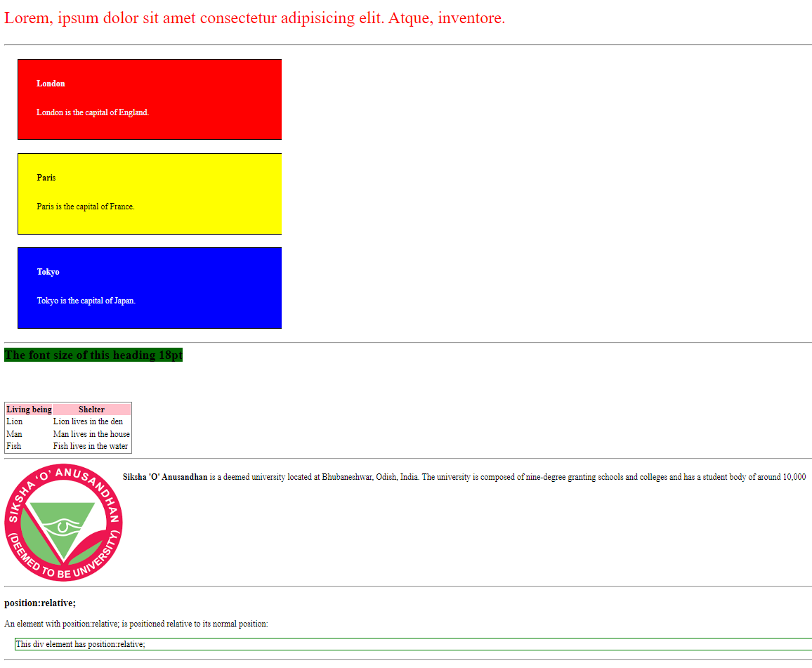

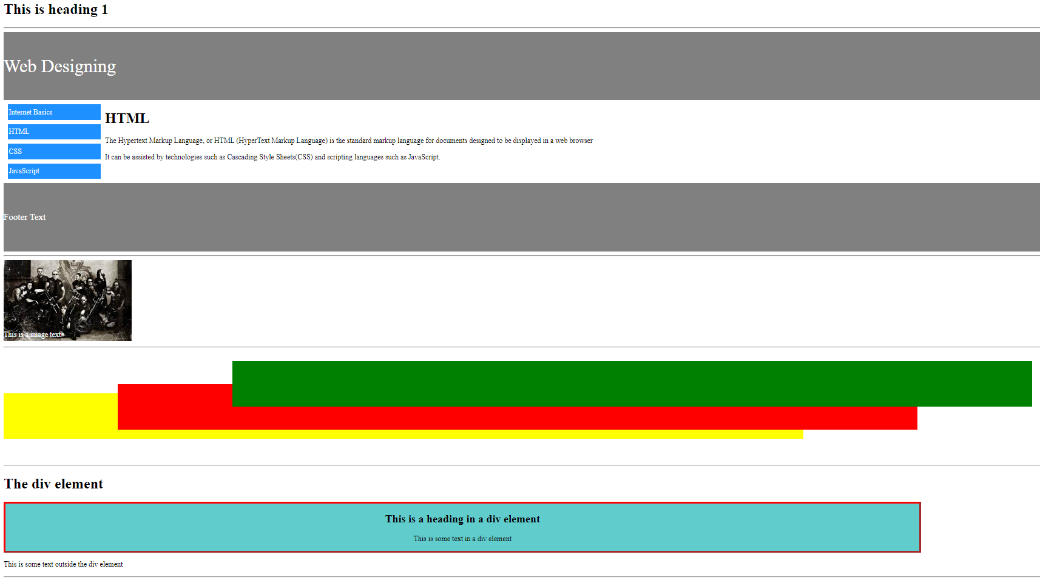

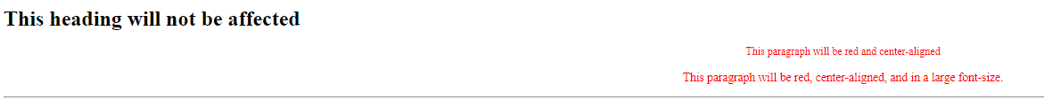

Name- Yash Raj

Regd. No.- 2041018031

Branch/sec- CSIT ‘C’

9)ASSIGNMENT 9: Create an HTML file of an animation created using CSS.

<!DOCTYPE html>

<html lang="en">

<head>

<meta charset="UTF-8">

<meta http-equiv="X-UA-Compatible" content="IE=edge">

<meta name="viewport" content="width=device-width, initial-scale=1.0">

<title>Document</title>

<link rel="stylesheet" href="css/style3.css">

</head>

<body>

<div class="container">

<div id="b1"></div>

<div id="b2"></div>

<div id="b3"></div>

<div id="b4"></div>

<div id="b5"></div>

<div id="b6"></div>

<div id="b7"></div>

<div id="b8"></div>

</div>

</body>

</html>

.container

{

height: 700px;

width: 100%;

background-color: darkcyan;

display: flex;

flex-direction: column;

}

#b1,#b2,#b3,#b4,#b5,#b6,#b7,#b8

{

height: 20px;

width: 30%;

background-color: darkmagenta;

margin: 20px;

padding: 20px;

border-radius: 10px;

box-shadow: 3px 4px 5px cyan;

animation-name: my;

animation-iteration-count: infinite;

animation-duration: 10s;

animation-delay: 1s;

}

#b1

{

transform: scale(0.5);

}

#b2

{

transform: scale(0.2);

}

#b3

{

transform: scale(0.4);

}

#b4

{

transform: scale(0.7);

}

#b5

{

transform: scale(0.9);

}

#b6

{

transform: scale(0.8);

}

#b7

{

transform: scale(0.5);

}

#b8

{

transform: scale(0.2);

}

@keyframes my

{

from

{

width: 30%;

}

to

{

width: 100%;

}

50%

{

background-color: cadetblue;

}

}



Name- Yash Raj

Regd. No.- 2041018031

Branch/sec- CSIT ‘C’

**10) ASSIGNMENT 10:** Create an HTML file having a design of ludo. Create using the different properties Of border.

<!DOCTYPE html>

<html lang="en">

<head>

<meta charset="UTF-8">

<meta http-equiv="X-UA-Compatible" content="IE=edge">

<meta name="viewport" content="width=device-width, initial-scale=1.0">

<title>Document</title>

<style>

.a

{

height: 100px;

width: 100px;

background-color: black;

border-top: 40px solid red;

border-left: 40px solid green;

border-right: 40px solid yellow;

border-bottom: 40px solid blue;

}

</style>

</head>

<body>

<div class="a"></div>

</body>

</html>



Name- Yash Raj

Regd. No.- 2041018031

Branch/sec- CSIT ‘C’

11) **ASSIGNMENT 11**: Create an HTML file diplaying all the basic elements of JavaScript such as console related fuction,print statement,conditions,etc.

Ans –

//equation and condition

var a=60;

var b=30;

//arithmetic

console.log("The value of a+b is =" + (a+b))

console.log("The value of a-b is =" + (a-b))

console.log("The value of a*b is =" + (a*b))

console.log("The value of a%b is =" + (a%b))

console.log("The value of a++ is =" + (a++))

console.log("The value of ++a is =" + (++a))

console.log("The value of a-- is =" + (a--))

console.log("The value of --a is =" + (--a))

//assignment operator

console.log("The value of a+b is =" + (a+=b))

console.log("The value of a-b is =" + (a-=b))

console.log("The value of a*b is =" + (a*=b))

console.log("The value of a%b is =" + (a%=b))

console.log("The value of a/b is =" + (a/=b))

console.log("The value of a^b is =" + (a**=b))

//comparison operator

let x=5;

let y=6;

console.log("Comparion")

console.log("The x==y is =" + (x==y))

console.log("The x!=y is =" + (x!=y))

console.log("The x===y is =" + (x===y))

console.log("The x!==y is =" + (x!==y))

console.log("The x>y is =" + (x>y))

console.log("The x< is =" + (x<y))

console.log("The x>= is =" + (x>=y))

console.log("The x<=y is =" + (x<=y))

//logical operator

console.log("logical")

if(x<0)

{

console.log("The value of x is less than 0")

}

else if(x>0 && x<5)

{

console.log("The value of x is less than 5")

}

else{

console.log("The value of x is greater than 5")

}

OUTPUT:

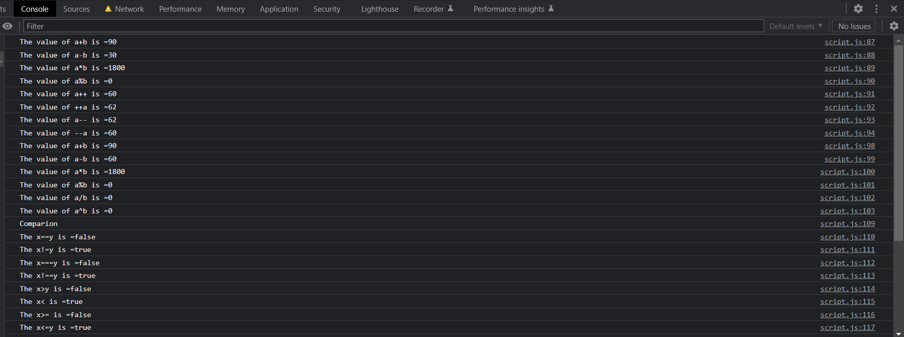

Name- Yash Raj

Regd. No.- 2041018031

Branch/sec- CSIT ‘C’

12) **ASSIGNMENT 12:** Create a Game of ROCK, PAPER, SCISSOR using loops and multiple if-else statements. Ask the user for input and generate a random output from computer and compare the results to display the winner in each round.

Ans – <!DOCTYPE html>

<html lang="en">

<head>

<meta charset="UTF-8">

<meta http-equiv="X-UA-Compatible" content="IE=edge">

<meta name="viewport" content="width=device-width, initial-scale=1.0">

<title></title>

</head>

<body>

<script src="js/script.js"></script>

</body>

</html>

JS- // Stone paper scissor

var player1=

{

stone:0,

paper:1,

scissor:2

}

console.log(player1)

for(let i=0;i<10;i++)

{

var a=prompt("Enter your choice")

console.log(a)

var b=Math.floor(Math.random()*3)

if ((a == 0 && b == 0) || (a == 1 && b == 1) || (a == 2 && b == 2)) {

console.log("Tie");

}

else if (a == 0 && b == 1) {

console.log("User won")

}

else if (a == 1 && b == 0) {

console.log("Computer won")

}

else if (a == 2 && b == 1) {

console.log("User won")

}

else if (a == 1 && b == 2) {

console.log("Computer won")

}

else if (a == 0 && b == 2) {

console.log("User won")

}

else if (a == 2 && b == 0) {

console.log("Computer won")

}

}

OUTPUT:

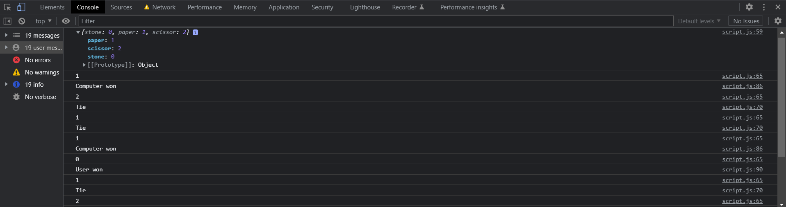

Name- Yash Raj

Regd. No.- 2041018031

Branch/sec- CSIT ‘C’

13) **ASSIGNMENT 13:** Create a vertical menu bar which will stick either on the left or right side of the page.

Ans - <!DOCTYPE html>

<html>

<head>

<link rel="stylesheet" href="css/style1.css">

</head>

<body>

<ul>

<li><a class="active" href="#home"><h1>Java Documentation</h1></a></li>

<li><a href="#news">Introduction</a></li>

<li><a href="#contact">What you should already know</a></li>

<li><a href="#about">Java Script and Java</a></li>

<li><a href="#about">Hello World</a></li>

<li><a href="#about">Java </a></li>

</ul>

<div style="margin-left:25%;padding:1px 16px;height:1000px; float: right; position: relative;margin-top: -270px;" >

<h2>Introduction</h2>

<hr>

<h3>Lorem 50 </h3>

</div>

</body>

</html>

CSS-

body {

margin: 0;

}

ul {

list-style-type: none;

margin: 0;

padding: 0;

width: 25%;

background-color: #f1f1f1;

position: sticky;

height: 100%;

overflow: auto;

}

li a {

display: block;

color: #000;

padding: 8px 16px;

text-decoration: none;

}

li a.active {

background-color: hotpink;

color: white;

}

li a:hover:not(.active) {

background-color: #555;

color: red;

}

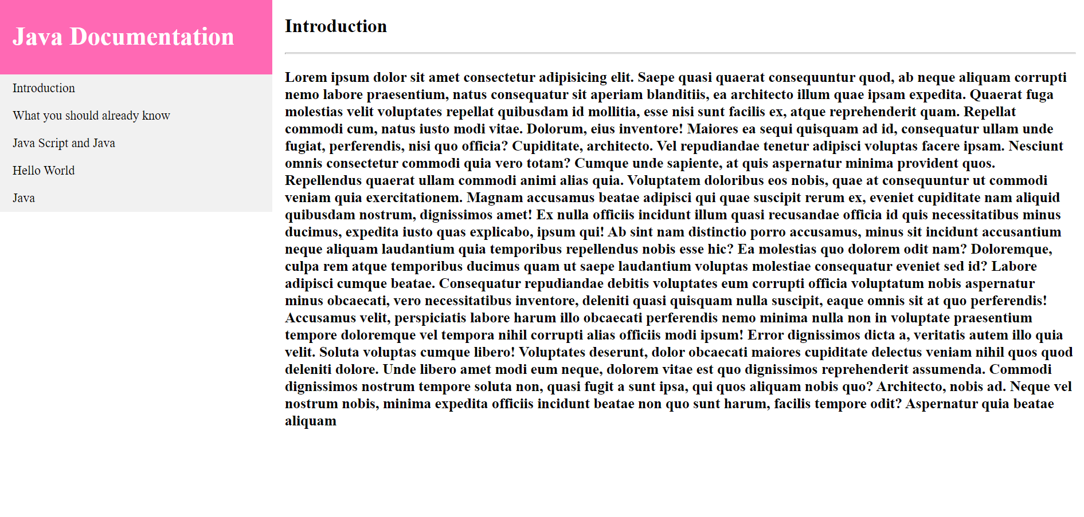OUTPUT:

Name- Yash Raj

Regd. No.- 2041018031

Branch/sec- CSIT ‘C’

14) **ASSIGNMENT 14:** Use the above created menu bar and make it movable so it will stay on the same position even after user scrolls down the page.

Ans - <!DOCTYPE html>

<html>

<head>

<link rel="stylesheet" href="css/style2.css">

</head>

<body>

<ul>

<li><a class="active" href="#home"><h1>Java Documentation</h1></a></li>

<li><a href="#news">Introduction</a></li>

<li><a href="#contact">What you should already know</a></li>

<li><a href="#about">Java Script and Java</a></li>

<li><a href="#about">Hello World</a></li>

<li><a href="#about">Java </a></li>

</ul>

<div style="margin-left:25%;padding:1px 16px;height:1000px;">

<h2>Introduction</h2>

<hr>

<h3>Lorem 50</h3>

</div>

</body>

</html>

CSS-

body {

margin: 0;

background-color: aquamarine;

}

ul {

list-style-type: none;

margin: 0;

padding: 0;

width: 25%;

background-color: #f9abab;

position: fixed;

height: 100%;

overflow: auto;

}

li a {

display: block;

color: #000;

padding: 8px 16px;

text-decoration: none;

}

li a.active {

background-color: crimson;

color: white;

}

li a:hover:not(.active) {

background-color: #555;

color: white;

}

OUTPUT-

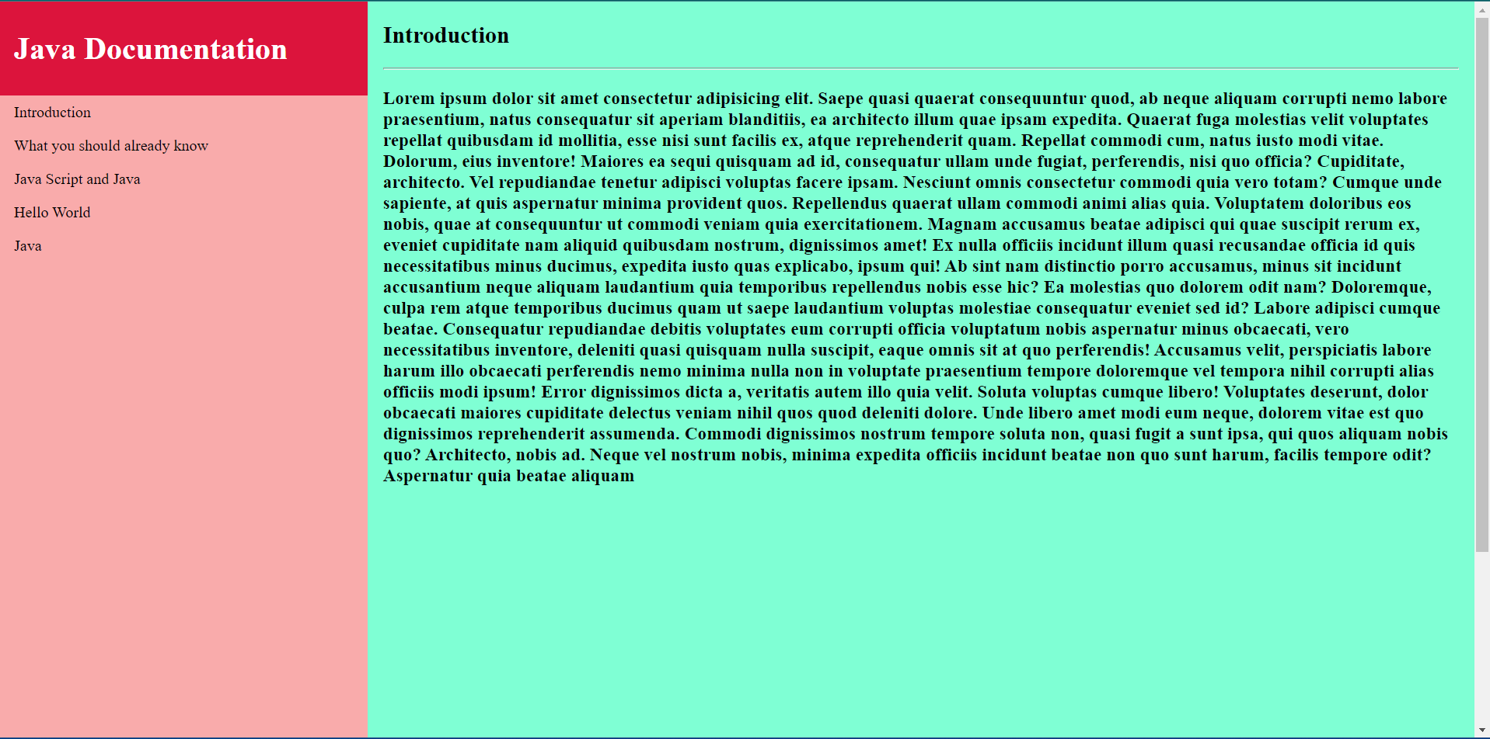

Name- Yash Raj

Regd. No.- 2041018031

Branch/sec- CSIT ‘C’

15) **ASSIGNMENT 15:** Add an image as a background to a div element and change the image source on mouse hover. In other words, when user hovers mouse on image it should change.

Ans- <!DOCTYPE html>

<html lang="en">

<head>

<meta charset="UTF-8">

<meta http-equiv="X-UA-Compatible" content="IE=edge">

<meta name="viewport" content="width=device-width, initial-scale=1.0">

<title>Document</title>

<style>

.a

{

width: 195px;

height: 130px;

border: 3px solid red;

background-image: url(https://api.time.com/wp-content/uploads/2019/09/american-flag-wind.jpg);

background-repeat: no-repeat;

background-size:contain;

}

.a:hover

{

background-image: url(https://static.toiimg.com/photo/msid-84475066,width-96,height-65.cms);

}

</style>

</head>

<body>

<div class="a"></div>

</body>

</html>

OUTPUT-

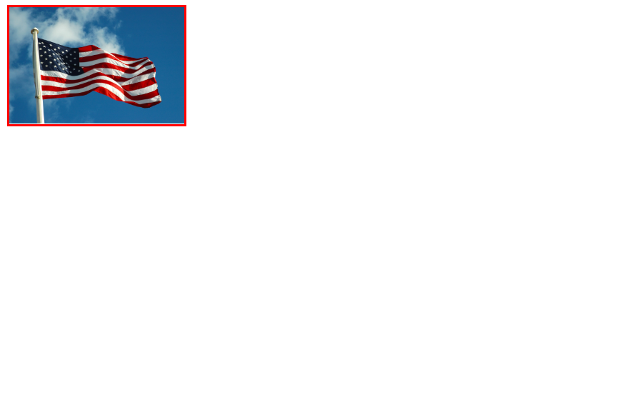

Name- Yash Raj

Regd. No.- 2041018031

Branch/sec- CSIT ‘C’

16) **ASSIGNMENT 16:** Add a div element and an image element. Write "My special div" as inline text in element like <div> My special Div </div>. Change the text color of div element when user use mouseover the div and change it back when u ser moves out of the image. Div

<!DOCTYPE html>

<html lang="en">

<head>

<meta charset="UTF-8">

<meta http-equiv="X-UA-Compatible" content="IE=edge">

<meta name="viewport" content="width=device-width, initial-scale=1.0">

<title>Document</title>

<style>

img.a:hover + div.b

{

color: green;

}

div

{

color: blue;

}

</style>

</head>

<body>

<img src="https://cdn.britannica.com/50/80550-050-5D392AC7/Scoops-kinds-ice-cream.jpg" alt="" class="a" style="height: 300px; width: 300px;">

<div class="b">My Special Div</div>

</body>

</html>

OUTPUT:

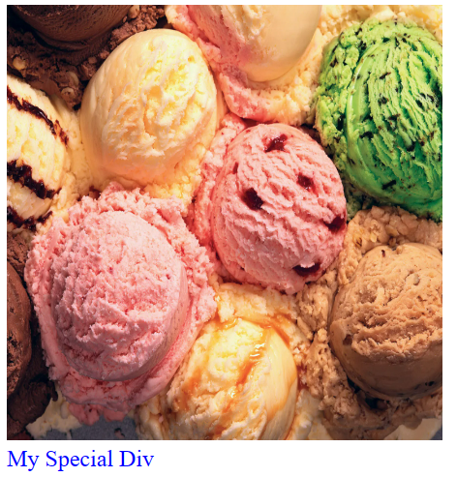

Name- Yash Raj

Regd. No.- 2041018031

Branch/sec- CSIT ‘C’

17**) ASSIGNMENT 17:** Add a drop down element with multiple values. Style each drop down entry differently like different font,color,size,etc.

Ans - <!DOCTYPE html>

<html lang="en">

<head>

<meta charset="UTF-8">

<meta http-equiv="X-UA-Compatible" content="IE=edge">

<meta name="viewport" content="width=device-width, initial-scale=1.0">

<title>Document</title>

<style>

ul

{

margin: 0;

padding: 0;

list-style-type: none;

background-color: black;

overflow: hidden;

}

li

{

float: left;

}

li a

{

text-decoration: none;

padding: 10px 103.39px;

text-align: center;

display: block;

}

#b

{

display: none;

position: absolute;

background-color: blueviolet;

width: 278px;

}

li a:hover

{

background-color: aquamarine;

color: white;

}

#a:hover #b

{

display:block;

}

</style>

</head>

<body>

<ul>

<li><a href="#">Home</a></li>

<li id="a"><a href="#">Contact Us</a>

<div id="b">

<a href="#">jio</a>

<a href="#">mio</a>

<a href="#">kio</a>

</div>

</li>

<li><a href="#">Goto</a></li>

<li><a href="#">Reply</a></li>

</ul>

</body>

</html>

OUTPUT-

